

August 1994

Inflation Report



August 1994

Recent developments in inflation

Retail prices

1.2 Output prices

.3 Domestic deflators

Core inflation

1.5 Summary

1. Money and interest rates
   1. Money and credit aggregates

Interest rates and exchange rates 16

Market developments 16

*Monetary sf‹itistics: current updating of*

*seasonal adjustments and new dcitabase 11*

*1s M0’s* growth *worrying for inflation ? 13*

ñsfimafing mn *rket expectatiOliS c›f*

|  |  |
| --- | --- |
| Demand and xupply | 19 |
| Demand | 19 |
| Personal sector | 20 |
| Corporate sector | 21 |
| External trade | 24 |
| Fiscal developments |  |
| 3.2 Supply | 25 |
| 3 *S* | 27 |
| *Land price.i* | 22 |

The labour market 28

##### Earnings 28

##### Employment 30

Unemployment 30

#### Productivity

4.6 34

*Box Employment.’ recent developments and data revisions*

Pricing behaviour 36



.1 External influences 36

Import and commodity prices

5.2 38

5.3 Profitability

Summary

##### The Bank’s medium-term projection

* 1. Private sector forecasts 44
  2. The main risks

Conclusions

Printed by Park Communications Ltd Bank of England 1994

ISBN 1 85730 097 1

ISSN 1353—6737

**Summary**

RPIX inflation—the Government’s target measure. based on the retail price index excluding mortgage interest payments—was 2.4&o in June. The Bank’s RPIY measure of underlying inflation, which excludes the VAT, local authority taxes and excise duties in RPIX, was 1.7%, close to its lowest ever. Most measures of inflation confirm that retail and output prices are not accelerating.

The signals from the monetary aggregates diverged slightly for most of the second quarter, with narrow money continuing to accelerate and broad money growing more slowly. But narrow money began to slow down in June and July. The financial markets have remained turbulent with concerns about the world recovery and the weakening dollar.

Output continues to grow above its long-run potential growth rate. Consumption appears to be holding up. in spite of negative wealth effects and the impact of tax rises on personal disposable income. Unemployment continues to fall. The slight tightening of the labour market is unlikely to have a substantial effect on the growth of earnings in the short term. Commodity prices and firms’ price ezpectations both give rise to risks to the inflation outlook.

The stance of monetary policy must be set on the basis of a judgment of where inflation will be in some two years or so. This is especially important at turning-points iii official interest rates. The pressures for higher inflation in the future may be building up even as the published inflation rate for the past continues to fall.

It is possible, though not yet certain, that the United Kingdom is entering this phase.

Underlying inflation may well fall a little further over the next quaner. The current picture of output growing above trend and inflation continuing to fall remains favourable. But if official interest rates were to remain unchanged.over the next two years, then it is probable that inflation would gradually rise to a .level above the mid-point,of the target range.



 



**Inflation**



**R**e**etai**i**l** rriicces

! ' ' '“ ' "’ The Government’s target inflation measure—the



j.J

##### 12-month rise in the retail price index excluding

* mortgage interest payme Tlts tRPl X)—changed little ovel

the three months to June. It fell from 2.49c in March to

- • 2.39r in April, a new low since the index began in 1975. ”" It then rose to 2.59r, before falling back to 2.4% in June

(see Chart 1.1).

**Chart 1.2**

**Goods and services** inflation

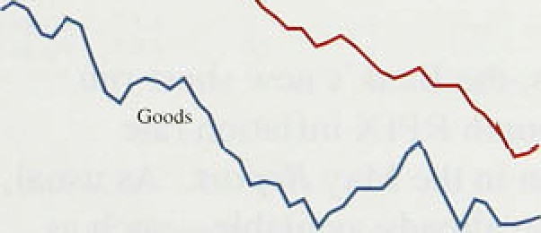

**Zsfile’1.A**

**Short-run méasuris of inflation**

One-off increases in indirect taxes like VAT boost RPIX and headline RPI inflation. To assess underlying inflation, the Bank calculates an index, RPIY, which excludes those taxes. The annual rate of RPIY inflation has fallen since the last *Report,* from 1.9% in March to 1.6% in April (another record low), and to 1.7% in May and June.

Headline RPI inflation rose from 2.3% in March to



* • 2.6' o in April, where it has remained. RPI, unlike RPIX, includes mortgage interest payments; the

' reduction in the rate for mortgage interest tax relief from 25&o to 209a in April was mainly responsible for the. increase relative to RPIX inflation. Chart 1.1 shows

_ , how ,the headline rate, which reached its trough in June 11993, can give a misleading impression of what is happening to underlying inflation: the Bank’s RPIY

.rate has fallen fairly steadily since September 1993.

Inflation, measured over the last year, continues to be lower for goods than for services (Chart 1.2). This is the.normal pattern, partly because productivity usually increases more rapidly in goods production.( But recently, services price inflation—measured over three months instead of a year—has fallen below goods price

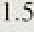

2.4 l.', I

-0:’8

›.2'

19

1,:2

inflation, similarly measured. Althou8h there has been



a tehdency for the decline in the inflation of prices of items which are not internationally tradable to lag behind that of headline inflation, this demonstrates that *ii* does.come down eventually. Short-run measures of inflation are shown in Table 1.A. The fail in the añnual!ised’thremmonih rate of increase.of RPIX



›:t.





C“harl I..3

Seasonal movements in prices of household guods



- 0

1 F bt A M 1 J A S O N D



Chart 1.I

RPIX inflation projections and outturns



(seasonally adjusted) was 1.6 percentage ploihts between March.and June—de"spite"the April tax iticre.ase's; which would normally have caused it to rise:

In the latest three months, inflation has been lower than projected in the May *Aeporf,* which was published before the .April RPI was released. The .main discrepancy was in April and the main reason was that

the normal seasonal pattern did not repeat itself this year. Typically, RPIX increases most in April, and least in July and January. The April increase is due partly to the introduction of new product lines. This year, though, spring discounts on household goods, clothing and footwear were much larger than projected in the May *Report* (see Chart 1.3 for household goods). Prices of household goods actually fell .in April, the .first April fall since the series began in 1974. These heavy discounts were not reversed in May, so it was not simply that price increases usually implemented in April had been delayed. In addition, foreign holidays were included in the RPI from last year and holidays,in the Unite‹i Kingdom from this year—changes which have reduced the usual April spike in prices for leisure services.

_ _ , In June, the slight fall in the level of.RPIX was as expected. Prices of seasonal food increased more than

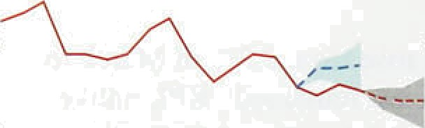

,--

_ _ anticipated and household goods’.prices stayed coristarit instead of falling. .But these were offset by

greater-than-expected falls in the prices of second-hand

#### * cars.and personal articles.

In the light of this news, the Bank’s new short-run



##### projection for the 12-month RPIX inflation rate

Tfie rongc i* dcfiecd cs ldc ccntial proj<cIion plvs a.r minus..ific.a\!crzge



Chart 1.o

Producer output price inflation

Change on year.earlier. u›ta1, urudjusied









(Chart 1.4) is lower than.in the May *Report.* As usual, .it incorporates information already.available-such as changes in telephone tariffs and petrol prices—plus statistical extrapolations!.of past price i.ncreases. lt'fs the

.benchmark.against which to.judge.the.’rrews content' of RPIX over the next.three months., Unlf!ke the1

.me.drum-term projection. discussed in Section.,6,.the short-run projection.does not embody the.Bank’s analysis of inflation prospits.



Anriuitl produe'‹ir pqtpat price i!nflatioii hñs fa!lien, sirice the Mcy *Rrpo*iT*.* :This his trite both for the series overall



él‘.ofi h1 h •s1›sni u1u*r°8«t•db›s*a'e-•*•e'a<:i

##### tax:!and commodity prices (Chart 1.5). The three-month !

me.asp.eretuding feod,,drink, tobacco.and petroleum turneñ.down in lone, having risen sink February.



Chart 1.6

producer output **prices and the price of**



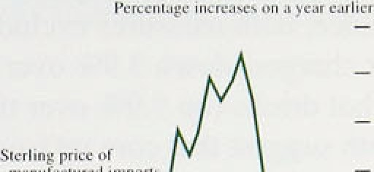

_ - 6





Table 1.B

**Domestic deflato xpenditure components**

Pcrcen\ego Gfianges on a yepr earlier

Conaump• invcsi- Govern- Exports Imports £iOP



t991 6.8 -O,fi' 7.0 l. I 0.4 5.B

j992 4.v -3. I 6.3 1.4 -0. I 4.ñ

1993QI 4.4 -O.8 6.4 10.3 R9 4.0

Q2 4.0 — 4.6 9.4 f0.6 3.?-

Q3 3.8 0.6 3.4 1 I.6 I I .0 3.3

Q I 3.B 0. I 3.6 7.7 3.* 4. I

l994 Qj 1.8 — 2.9 0.6 -0.9 3.3

Seasonally adjusted gmwih rate.s—l993—94

Q4 on Q3 1.5 -0.2 2.0 — -1.2 0.9

QI nn g4 0.9 -0, j 1.0 -0.I -0.3 o.7

**Chart 1.7**

**Alternative measures of ‘core’ inflation**

Chart 1.6 shows that the sterling prices of imported manufactures decelerated from September 1993. Like domestic output, these goods are used both as intermediate inputs and to satisfy final demand. The prices of manufactured goods bought by distributors and retailers are an Important influence on prices to the final

consumer.

### 3 D mest def a o s

Table 1.B reports the annual inflation rates of the price deflators for the major categories of expenditure used in the Natlonal Accounts. Since the May *Re Port,* these have been revised back to the beginnlng of 1992. In particular. estimated annual import price inflation has been revised upwards for 1993, by as much as 1.4 percentage points in Q4. More of the price increases reflected in these deflators resulted from imports than previously thought, and less from domestic value added. The effect has been to reduce the estimated increase in the GDP deflator over the year to 1993 Q a measure of domestically generated inflation—to 4.19 from 4.8%.

The new data for 1994 Q1 show a drop in the annual inflation rates for all expenditure categories and in the quarterly rates for most of them. There was a particularly sharp fall in the annual rate for expon prices. which suggests that the effect of sterling’s depreciation towards the end of 1992 has worked itself out. Annual GDP deflator inflation fell to 3.39•, consistent with the fall in domestic producer price inflation in the first quarter. The fall in inflation measured by the consumption deflator from 1993 Q4 to 1994 Q1 is somewhat larger than the fall in RPIX inflation.

# 1.4 Core inflation

* + "" "“ " ”"”"“ "' '° Price changes caused directly by policy can obscure the qgq „„q „, underlying or ‘core’ inflation that reflects wage and
  + — • price-setting behaviour. This is why RPIY excludes the Council Tax, indirect taxes and mortgage interest

’" — ‹ payments.

Tdmiic6 rriean

— - 4





t99.1 9t . 93 94

But RPIY is not the only measure of core inflation; two others are shown in Chart 1.7. The median inflation rate is the weighted median of all the 12-month increases of the components of the RPI, and the trimmed-mean inflation rate excludes the largest and smallest 15% of 12-month price increases. The proportion of price

7

lflflulion Rejxirl;Augiist 1994

changes left out is an arbitrary figure, but is intended.to exclude the larger price movements, as these are likely to reflect one-off factors such,as tax changes. In the latest month, for instance, both measures exclude telephone and similar charges (down 3.9&r over the year) and coffee and hot ‹irinks (up 9.9% over the year). The two measures both suggest that core inflation has remained at just below 3&o throughout the first half of 1994. They exclude some of the components included in RPIY which showed unexpectedly low price increases this April. Such measures are slow to reflect general increases or reductions in inflation when these affect different sectors of the economy at different times; unusually large price changes which are precursors of a general inflationary shock are ignored.



RPI. ’FPl rind H t RI' inflation rates

Pcrccniogc increases in prices on a year earlier

— — 6

— — 0

UI 9* 93 94

Chart 1.8 shows two more .inflation measures, the housing-adjusted.RPI (HARP index) and the Tax and Price Index (TPI). The exclusion of mortgage interest payments from RPIY and RPIX avoids distortions caused by changes .in interest rates, but at the cost of ignoring the price of housing completely. The HARP index rectifies this by replacing the mortgage interest component of the RPI with a Bank estimate of the user-cost of housing. This means that house prices

.affect the index, and their recent weakness caused HARP

inflation to .fall in the second quarter.

The TPI adjusts the RPI for changes in direct taxation so. as to obtain an index of consumers’ purchasing power.

If direct taxes go up, purchasing powerlfalls and the TPI rises, even when headline RPI does not change. .Hence the TPI is a useful indicator of one ma)or factor determining employees' wage claims. From April. increases in income tax and national insurance contributions pushed TPI .inflation iiirther above RPIX inflation.



R.PIX in.flation the ,Government’s target measur was 2,4&o in June. .Price increases ,between March and'April were unusual.1y small. The thank's RPIY measure!of underlying. inflation was I.7& in June,. close .to its

.lowest ever .and i-iARP inflation was 2'2âo! Mast

:measures ,of3nilatioa confirm that retail and output pnces are not accelerating, although tliere,was a'smalI Mse iq shoft-inn RPIY inflation in,June. ‘



**Table 2A**

Notes and coin .April 0.6 7,2 7.'5 6:4

’1 e’ 0.’6 7: 7: 6:7



May 0.5 ?.7

Jute 0.5 8.3 6:9 6.9

.july (by 0.7 6.5 8.1 6.5

The May *Inflation Report* identified the pace of monetary growth, in particular that of narrow money, as a threat to the inflation outlook. The signals from the monetary aggregates diverged slightly in the second quarter, with narrow money continuing to accelerate over the period as a whole, but decelerating in June and July, and broad money growing more slowly (see

Table 2.A). Annual M0 growth remained well above its

M4 March 0.6 6:8 6.9 5.7

April 0.2 

:Ma)i If.3 4.5 5.3. 5 3

*I* arc*L* 0.4 2.8 3.2 3.4.

-Apñ1 0.1 3.1 3.0 3.1

Ma'}' 0.3 3.4 3:I 3. I

June: O.S. 3.5 3.1 3.5



0%—49a monitoring range, at 6.59c in July compared with 6.0% in April. M4’s annual growth rate declined to *5.â%* in June, below the middle of its 3&o—99a

monitoring range. Credit growth is still modest, with companies repaying bank debt (see Chan 2.1).





**Chart2.l**

I.3

3.8'



Because narrow money is demand-determined, M0 (and particularly its notes and coin component) tends to move roughly in line with measures of cash-financed

spending. In the first six months of 1994, the monthly growth of notes and coin averaged 0.6%, continuing the strong run since last November. Notes and coin rose by

**l2•oiontli growth ratm of MO, M4, Dlvisfa**



- '4



##### 0.4% in July, and were .up 6.5% on a year earlier.

.Although growth in narrow money in the first seven months of 1994 has been faster than would have been forecast, .recent Bank research (see the box on page l3) suggests narrow money will deeelerate. But it is not easy to explain changes in currency holdings. Thete has long been speculation about the impact of the ‘black market’ economy on narrow money growth. Changes in currency may, therefore, proxy unrecorded expenditures which affect activity and inflation with a lag.

##### As for broader measures Of money, they correspond

- .° most closely to the monetary variables in the transmission mechanism between monetary policy and aggregate demand., The UK measure of broad money,

.M4„ is used both to finance.transactions and for savings and portfolio purposes. This.means that broad money is related,to ñOth nominal income and wealth, and .can provide additional information about spending, activity

**se qoa1•4jU•ments.and.a neg...comjuter'.database which incorporates a..**

**-nutriber pf,da6 revisions. Tht tioX** on! page .11.provides further detaib of

:9

in the\it›n kept›rt: August 1994

and future inflation. The links b’etween broad money and inflation are not straightforward, however, and!.it is helpful to disaggregate the total .into sectoral components.

After reaching a recent peak of 5.7% in March (the highest rate for two years), M4 growth weakened during the second quarter. Its 12-month growth rate fell in April and then again in May .to 5.3%, but increased to 5.6% in June, partly because a low monthly growth rate of 0.1&c in June 1993 fell out of the calculation. In the second quarter of 1994, the monthly growth rate for M4 averaged 0.3%, compared with 0.5% in the previous three months. As a result, its shorter-term growth rates declined sharply—the three and six-month annualized rates stood at 3.6% and 5.2'7o respectively, .compared with 6.89o and 6.9% in March.

During the period of sustained acceleration in 1993 and the first three months of 1994. around three quarters of the increase in M4 was accounted for by retail M4. In the second quarter, however, the retail component was particularly weak—increasing by 0.5% over the quarter (compared with *I .6%* .in the previous quarter)—and explained only 43% of the growth in M4. Within the components of retail M4, banks’ retail deposits increased by only £0.8 billion (0.4%)—the smallest quarterly increase for nearly two years. Indeed, bank non-interest-bearing deposits fell ñy £0.3 lbillion. .But bank interest-bearing deposits were also subdued—they grew by £1.1 billion—compared with an average of

£2.0 billion in the four previous quarters. Building society retail deposits have been particularly weak this year, but do not explain the weakening in retail M4 since March. Indeed their net retail deposits (excluding interest lcrediting) .have now recorded outflows in seas:onally adjusted terms for eight successive months.

Whereas building.society retail balances are predominantly personal, banks’ retail deposits are not

.synony!mous with personal sector deposits.. Addi!tiona1 i.nformation is therefore available. from disaggregated

.sectoral holdings.

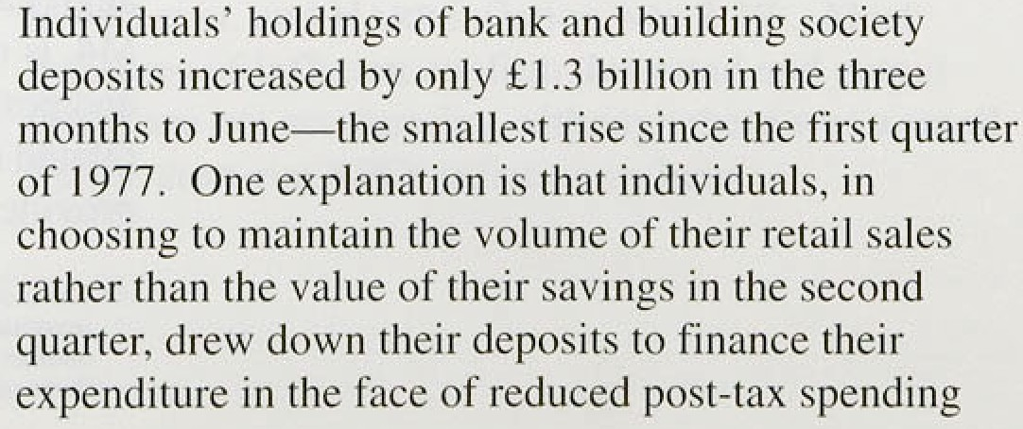



# Monetary statistics: current updati*g ,âf,sea§oqa1 adjustmenJs and new,dlatafiase:

The monetary. data published: on 20 Juñé incprporatefi current updating of tlie seasonal adjustments. for the first ti:me. Previously,the seasona:1s were up.dated.half yenrly:

Current updating re-estimates the seasonal

.adjustitients each.month usi.n.g! the latest obscreations. The main advantage of using. this method is that it should réduce the average size of revisions to tire seasonal adjustments, since tiiey will already take into account the latest inforrñatioh! on emefgiiig in seasonality; revisions„will.be. more frequent. but revisions other than to.the satñe period a year earl



new information about seasonality in the latest month is reflected.iii the ‹iata‹for the same month

ed).are’uiil.ikely to be material.



As well as the move to current updating, the monetary statistics are.now ’co9structed using a new computer database and change‹i,methods of calculation. These factors have. led:.to.re,visions in the data:

0 The strong growth in narrow money **recorde‹i in** April was removed by current **updating.and rep1ace‹i** by a monthly growth rate’in line wi.tit that seen over the previous:: six inonth-s

May’s notes..and. cotn !and. M0.growth increased from }Jrovisioiial. rates, of.0.5&• anal 0.29• to 0.7% and 0.5% respectively:

Current updating has had little impact on the I.2-month growth rates .of: narrow money: the rates for May have been revised down slightly, as have the shorter-period rates:

The main reason for the generally downward revisions to M4’s growth rates .in the past three years is the revised treatment of the discrepancy in banks’ reporting of their sterling domestic interbank business: Following a detailed investigation of i.ts. causes by the British Bankers’ Association, most of the sterling iriterbañk difference is now included .in..M4 itsel-f:. The contraction of the discrepancy (a net liabilit:y of UK banks) in recent years .has reduced M4's growth rate.

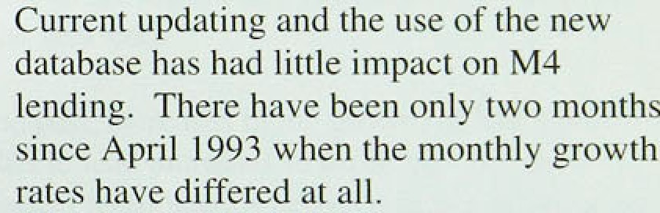

power. In addition, with average bank and building society deposit rates falling slightly over recent months, competition from other investment products has continued, prompting several building societies to offer other forms of investment, such as the recently launched stepped fixed-rate bonds. The depositing behaviour of industrial and commercial companies (ICCs) has also contributed to the deceleration in retail deposits: following the strong rise of £3.2 billion in the first three months of 1994, ICCs’ holdings of M4 deposits increased by only £0.7 billion, the smallest increase sincle the fourih quarter of 1992.

The, Bank’s .Divisia measure of money, which weights the various components of M4 according to their transactions characteristics, confirms the above sectoral

.ahalysis:. Follow.ing.four consecutive quarters of increases, ,the annual growth rate of aggregate Divisia

lutltition Repori! Auguit 1994

fell in the second quarter from 3.9&n to 3.5%. Both personal:and corporate sector Divisia fell 0..6&r over the quarter; their annual growth rates !stood at 2.3% and

.8.09a respectively in June, compared with 4.5% and 10.8% in March. The scale of these declines is related to the fall in both personal and corporate retail .deposits, the components that.receive .the highest weighting within Dlvisia.

Following the recent recession, credit growth has remained subdued. The annual growth rate of lending by banks and building societies was 3.She.in June, well under half the annual rate recorded at:compoable points in previous.recoveries. Lending to individuals increased by £5.9 billion in the second quarter; compared with

£6.2 billion in the previous quarter. Within this, lendi.ng for house purchase rose by £4.9 billion (deflated by

£0.2 billion of securitisations), below the £5.fi billion (inflated by a £0.2 billion transfer of loans) recorcled in the first quarter of 1994, but slightly higher than the quarterly average in 1993.

This pattern is .consistent with the slight downturn in housing market,activity seen in recent months (see Section 3), which in turn might be related to the increasing rates charged on fixed-rate mortgage products. Since the May *Repprf,* :average .three and five-year fixed rates have inerease‹i .by around 1.5 and

1.7 percentage points respectively and now exceed the average variable rate. Mortgage lenders have recently been .offering attractive discounted mongages and cash incentives in an attempt to persuade individuals .to take! up variable-rate products.

Len‹ii!ng for consumption, however, .i.ncrease.d by

£1.0 billion, the strongest quarterly rise since the first quarter of 1990; the increase was entirely accounted for by banks. In particular, the rise in bank credit card lending, at f0.4 billion, was the strongest since 1950 Q4, and other consumer credit w.ent up..by nearly

£0.ñ billion, the highest rise since the third quarter of 1992.

Following seven consecutive quarters, of net debt repayments, unincorporated busihesses borrowed

#### £0.1 ,billion in!t$e.second darter. This rise in

it

bf these b s bee te .’ 'l i.nties'day bt! ge c inbl k

and that a gi atér proportion of future income may be used for.spending,.rather than to:repay existing debt.

I2:

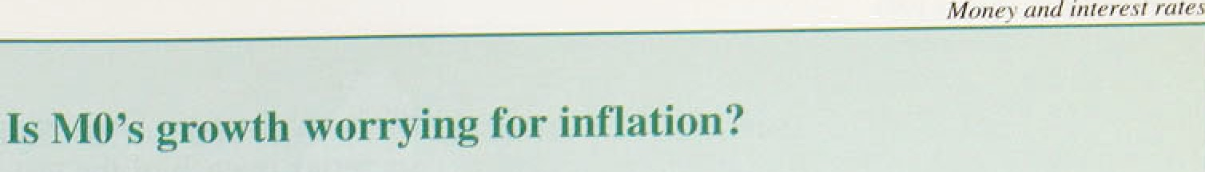

May’s *Inflation Repart* highlighted thq continued: 

ran.8e!as a risk to ,the inflation outlook. Annual M0 growtli stood at 6.08b in April, Thereafter it peaked.at 7.08•!’.in **ivlay**



apd has subsequently fallen ñack to **6.59»** in July..

This raises two,questions. Can we explain the

current growth or narrow money? And does it -

**suggest** higlier inHation in .the future?

Previous. Bank research;: summarised iii an article published in the February.’Quarte!rly *Bulletin,(*

examined the determinañts of M0 and provided a - ‹.

framewotk within wliich to.answer these questions.

It concluded.that the three main deterininants of M0 "

are: (i) econoinic ctivity; .(ii/) !the level of.interest rates; .and (ii.i) tlie rate of iqnovati9ns in the use of cash.. Tliis last factor evolves:s1owly, .and

. determines the treritl in'the velocity ,of.M0. ”’ "

The.analysis ,(based on.monthl.y adi..quarterly observations) foiind that the activity measure most closely related to M0 is retail sales, and that the trentl in. velocity is best proxied by a term.that cuniulates interest rates, These monthly and q.uarterly inofiels. tiave since been re-estimated over

.a longer:sample period (to 1994 Q l),.which resulted iii a signi;ficant reduction iii. the interest sensitivity irriplied by\the monthly rrioñel.

The'.Chart reports forecasts..ñas.ed on ttiis rñodel, conditioned on the end-t993, level ñf narrow .money, when.the.level.of M0. was probably close to trend. in. addifion,..a.forecast basefi.on the! Treasury’s.:



:measuze.and: a.time.trend to proxy developments: in.

:trdcid’”vetocity: ?*

the conclusion that it is not easy to explain. all of the. increase in narrow money growth since the beginning of the year seems reasonably robust.

Furthermore, on the basis of the latest outtums, all three models forecast an average monthly growth rate for narrow money in the region of 0.3% to. 0.4% over the next five months. This would .result .in a decline in the annual rate to around 5'/2&o to 6'/‹%

by the year-end. 3)

In the past, increases in the growth of M0 havg tended to lead increases in inflation. But the statistical relationships between future.iiiflation! dnd MO do not have a firm :structural!fiasis. In, particular, there are factors which econometric models do not take account of/which..could;boost



without.stiniulatiñg'inflation for examplei:changes.’



Tlie annual growfh’in narrow money is currently

in. em

that reflect increased cash„

t/i& to,1& more than **tkese** mo‹iels.would have forecast at the, start of the ,year. These differences

.emphasise how ensitive forecasts are .to tire .precise empirical relatioqship assuaged between MO.and its detenoinants. This .is especially clear,wlien **comparing** the )Sâoic’s m**onthly an‹i** quarterly model

**.facts,** wliioh.are based **on..a eommoq** theoretical



.rather ihan direct":bank traiisfer, wagesettlemenfs,. or. ñlack economy growth. But data on a1l':these are’'

ver scre, making assessment of the possible

.:quañtitative.importance of these.factors very

.difficult.

:Thus, i.f M0.gidwth remains at.its.present rate throughout the.rest of the .yet, concerns over futiiSri inflation would.increase„exen though factors whose: influence we cannot measure might distort this'

.signal:

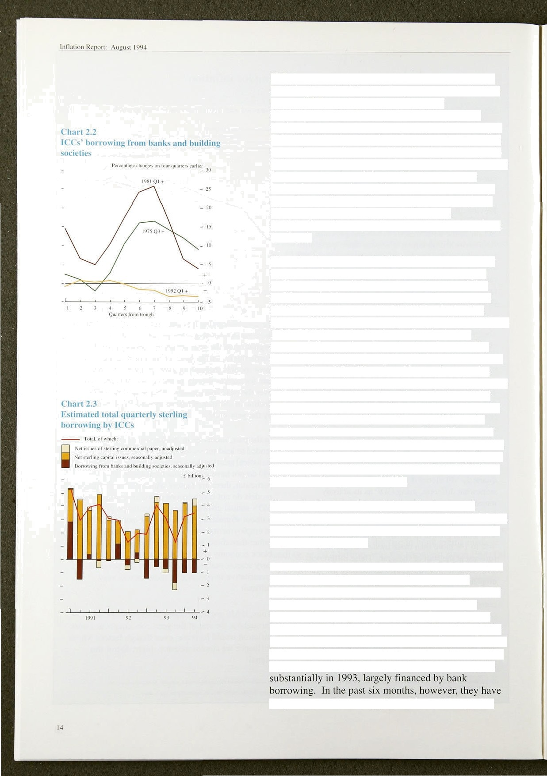ICCs have repaid borrowing from banks and building societies in each of the last six quarters. As in the first quarter, ICCs repaid debt in the region of

£1. l billion in Q2. This sustained debt repayment during the present economic recovery contrasts sharply with the marked increase in ICCs’ borrowing in earlier recoveries—see Chart 2.2. This illustrates the key role that companies’ balance-sheet restructuring is playing in the current recovery. It is possible that even now residual debt remains at higher levels than companies regard as satisfactory. For the corporate sector, bank finance appears to have been replaced by a

combination of net capital issues and retained earnings

(savings).

There has been a marked shift in the current recovery towards capital market finance, in comparison with earlier recoveries. In the most recent quarter, ICCs’ sterling capital issues remained relatively buoyant at fi3.9 billion, compared with £4.1 billion in the first quarter of 1994 and a quarterly average of £3.8 billion in 1993. ICCs’ total sterling borrowing, including commercial paper, is estimated to have increased by

£3.4 billion, compared with £3.1 billion in the previous quaner (Chart 2.3). There is evidence of companies postponing share issues because of the recent turbulence in the financial markets. In particular, in June ICCs’ capital issues would have been markedly lower but for the sizable Eurotunnel issue. However, if financial market turbulence continues to subside. ICCs’ use of non-bank finance might increase in the coming months. ICCs’ retained earnings have increased steadily, from a trough of 6.6% in the first quarter of 1992 to 10.2% of GDP in the first quarter of 1994.

These developments in capital market issues and retained earnings suggest that there are substantial funds available in the company sector to finance increases in discretionary spending.

Other financial institutions borrowed £0.5 billion in the second quarter, following a small repayment of

fi0.3 billion in the first quarter. The weakness in OFIs’ bank borrowing is largely explained by securities dealers. Over the past six months, borrowing by the gilt-edged market has fallen considerably, although the scale of repayments of bank borrowing was much lower in the second quarter than in the previous three months.

Gilt-edged market-makers built up their stock of gilts

#### fully unwound their long gilt position. Although this

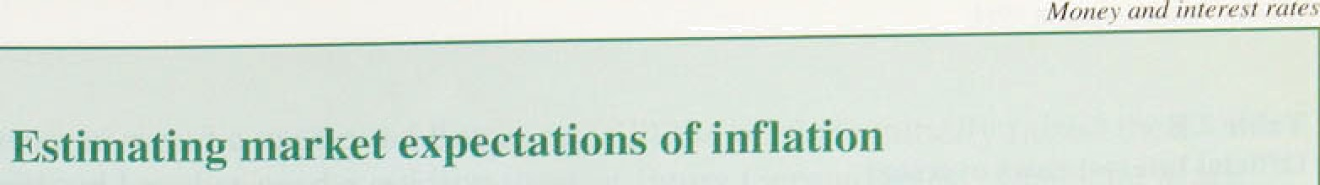

Charts showing Estimates of bond ,iriarket expectations of inflation at a range.of future

.da?es were first published in the. May 1993

*Inflaiion Report.* Since then, reselarch Unto the

.appropfiate. inethod has continued. The Bank’s preliminary work’was discussed at a one-day conferénce in I\Jarch organised by the Bank. in which résearchers from other central banks and acafiemics took part. Their comméiits and further research have suggested a number of possible alternative rrrethods to that used currently .by the Bank. These!issues are outlined héré ahd’!explored i.n more detail in an article 'in ’the August.edition .of the *Quai‘tri lv*

*.Butletin.(!*

However; there. are a .number of important i3sties in the estimatiori..of yield curves—for exarñple, how smooth shoul‹J it be* How shoul‹i borid-speci.fic ’effects be removed?

Researcb.at the Bank has coinpare‹i the current

method to!others suggested in the academic literature arid has highliyhte0 how differen’t approaches can produce very different results. The Chan below shows irñplied forward rate curves produced using three different methods

Ithe current method. used in the: *hiflation Reyo*rt and those due to McCulloch and S!veiisson in the. academic l.iterature see the Bufleiiit article for full references) and highlights just how different the curves can be. Most of the significant differences occur at very long.

The sirñplqst.method for deriving estimates ot’ maturities—20 years or more.

.inflation .expectations is to substract the yield

on an indent-linked gilt .from the yield on a  Conventional gilt. Therelare several problems in

trying to ^inierpret such numbers as estimates of market inflation expectations. First, the yield on an individual gilt (particularly on a conventional) can be distorted by a number of factors riot'least by the si.ze of its coupon payménts., This ineahs that two. bonds with the same. maturity: may .have significantly different yields.. Second,..theye are ‘gaps’ in the maturity spectruin for which there are qo bonds— nioreov!er„.only one o.f the required pair may exist at.a.pa'iticular maturity of interest. Finally,

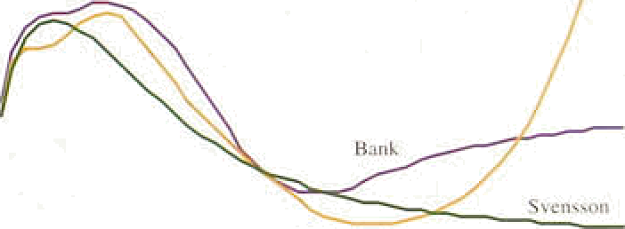

|  |  |  |  |  |  |
| --- | --- | --- | --- | --- | --- |
|  | | | SI -t’u I Fch |  | - |
| ' 4 t | s | l i i $g1 | 14 If | I S | 4 * ’ |

’such measures represent *average* inflation expectations! over:the whole rnatu.rity in

question, whereas for tile ,purpose of monetary policy:Analysis it.is.!the niârginnf.rates (re ’expectations of the siiort-run rates that wil.l

i.i i Band Un price› ‹›n 7 in nc 1 994.

Having. decided!on a model. and:adapte:d:it. to model the in‹iex-linked market .so as'to obtain a.

l

a llie esn

the fumre) that are.perhaps: of. more

.real yield curve. :the implied.forward inflation rate. is clerived by substracti.rig tire.rea! iiom .thé forward rate.curve. .

To avoid such problems, i.t.is neciissary! to

estimate *yrefd curves* for both the cpnvéntiorial The *Bulle(in* article outlines various. yield curve and index-linked gi!lt markets. .A c:ontinuous models.and presents the. results of preliminary **corve** will provide an expectafion **for** every analysis carried out in'the Bank comparing the **maturity of interest. Havi.rig estimated** the yield !methods. The performance of.the models will



*implied forward rate cu*re*e‘* that represents.the intention of'idenñfyi.rig the most suitable. in.!tirñe





lntJaii‹» Rcpt›rt: August I ‹J94













|  |  |  |  |  |  |  |
| --- | --- | --- | --- | --- | --- | --- |
|  | .),21 | ?.]() | 2.>() | 2.25 | 2.19 | 2.09 |
| Dr ,cou@ | 1st | 675 | 175 | 175 | lUU | 4.’5U |
|  | l0o | 7vj | €7f | 7g | ajw | g.0 |

FrBnce:









f‹ir Tlecens hrr 1994':

will have been a factor.In recent:market falls, its impact will have been reduced.by the unw!inding of swap positions which. hedged the initial build-up of gilt positions.

Turning to the other counterparts of M4, the public sector contribution (PSBR net of gilt sales to the M4 private sector) totalled £4.5 billion in,the second quarter, compared with £8.2 billion in the previous quarter.

These sizable contributions in the first.six months of 1 1994 were partly explained by the lower take-up of gilts by the M4 private sector during!the ñondl market. turbulence. Total external and foreign. currency flows made. a .large negative contribution (£3.8 billion!) to..M4 growth in the second quarter, following four successive quarters of positive contributions. This is largely explained by the substantial increase in net foreign currency deposits he1‹i by the private sector which, in turn, appears related to .OFIs’ increasing foreign currency deposits.

"' ‹

ey2e

te a d h e te

*Matt ket developments*

- - ?.2





**Table 2.C**

Det elopnients in financial **markets** of the G10



Changes between 1 Febru ury and 27 I uly 1994: rfiriiipys Grrii'eeif' 4 ñfej•



Long-dated Egui’\ies ‹hj Effective: bond yields faj ipercenia§ e exchange' rots. (basis point change) (percenui@e

chan$cj " " than )



1.1 Ma, The cuts.were larger than the markets hand



i6.

The financial .markets have remained volatilelin the past. three months. In May and June the bond markets were affected, in June and July the fomign exchange markets. UK gilts and eqluities weakened in May and June,'and the same was true of other European countries and the United S.tates.. More recently,.a1!l European. markets

and particularly the UK. bond..markets.appear to havq

##### steadied.

Although official rates in the .United Iiingdorn lhave n.ot changed:since. Febmary, several G10 coun.tries have. altered their.official rates. since,the:May *RRp,!or,t*

(Table 2.B). The Federal Reserve raised the target federa:l funds rate by a further 30 basis potnts: on ..

17 May.. This took.the rate: up.to 4.25 •; from:3:0% at

##### the start of.this year. :Market,expectations about hiture



the year. For example, the future US.ratns implied by’

.futures pncgs stooâ; at.5.2&o.an It fi.0&o for September and .December contract 9n 27 July,:co.mpared with 4.1.9« and 4.4 ». respectively on 2. Febniary., However,

*Money and: interest rotes*

.Chart.2d

Rise in bond yields And past inflation







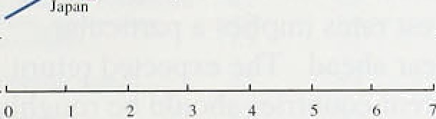

-0.5

(é Soi«x: OECDEmmomicOuCm<D•mcmMrl993.

Chart 2.6

Implied forward nominal interest rates

_



27 July

4My





1.995. 2000 . . 05. 10'

**Chart fi.7**

**UK implied bond market .volatility** .‹•›

'tmgt*ied volaIIIi\y fper cen\}{bT

- — 16



ease repo rates I) the markets initially raised their

,e'xpectations of future German rates: .Deutsche Matk futures prices reached a local tro9gh on 23 May, sug.gesting three-month money at 5.3& in December 1994. Expectations have since come down slightly: interest rate futures on 27 July suggested three-month money at 4.99r in September, rising to 5.0% in December and 5.2% in March of 1995. These compare witfi 4.9%, 5.0% and 5.1% respectively on 4 May.

Table 2.C summarises developments in G10 financial markets since the Federal Reserve’s move in early February and during the period since the May *Inflation*

*Report.* Yields in all major bond markets have risen further since May. Since early February, the strongest rises in ten-year government bond yields have been in the United Kingdom, Italy, Canada and Sweden. During the rally in 1993, these countries’ bond prices rose most sharply.

The pattern of this year’s reversal seems to be linked also to countries’ inflation records. There is a statistically significant cross-sectional relationship between this year’s rise in bond yields and average annual inflation rates since 1984 (see Chart 2.5). This suggests that the long-term credibility of monetary policy played an important part in the recent behaviour of bond yields and inflation expectations.

The current structure of short-sterling futures prices suggests that, as at the time of the May *Rep.ort,* markets expect the next move in interest rates to be up.

Three-month money rates at 27 July stood at 5.6% for September contracts. rising to 6.3% by December and 7.0% by March 1995. Beyond that, implied forward rates suggest that short-term interest rates are expected to reach a peak of just under 10% around the year 1998 (Chart 2.6). Since May, the implied inflation rate in the medium term has shifted down (see Chart 6.5 on

page 45); peak expectations are now about 6.0%, at maturities around 2000.

That.the bond markets remain disturbed is evident from " the implied **volatility** on long gilt futures contracts (see

Chart 2.7). This suggests that uncertainties have remained at similar levels to those at the time of the last

“ *Red pr.t.* C'iiven these uncertainties, the interpretation of **day-to-day** movements in implied forward interest and **inflation** rates **must** be guardeil. Implied forward



**:réduclion of.three:haâis•i›i** inis,





int’lation rates have fluctuated either side of their level at the time of the May *Inflation Repnrt.*

The effective exchange rate for sterling slipped below

79.0 on 12 July and again on 26 July, partly because of the weakening dollar and the tendency of sterling to move in sympathy with the dollar against other currencies (Table 2.D). Since the May before, sterling’s ERI has fallen by 1.3%, compared with a fall of 3.2% in the dollar’s index.

On the assumption of uncovered interest rate parity, the pattern of expected interest rates implies a particular path for sterling in the year ahead. The expected return on similar assets in different countries should be roughly the same. If, for example, domestic interest rates are higher than foreign rates, this means that sterling is expected to depreciate slightly, to offset the interest rate differential. This parity condition applies only to expected returns, and oniy to comparisons of returns on assets with common characteristics, such as credit risk and liquidity.

The interest rate differential between the United Kingdom and the trade-weighted world average widened over the period since the May *Report,* with UK rates increasing by more than the world average

(see Chart 2.8). At the time of the last *Report,* the differential was around 10 basis points for three-month interest rates and 60 basis points for 12-month rates. On 27 July, it was around 20 and 65 basis points respectively. This implies that sterling’s effective rate is expected to fall over the next year by slightly more than was the case at the time of the last *Report.*

**UK trade- 'eighted interest rate differentials**

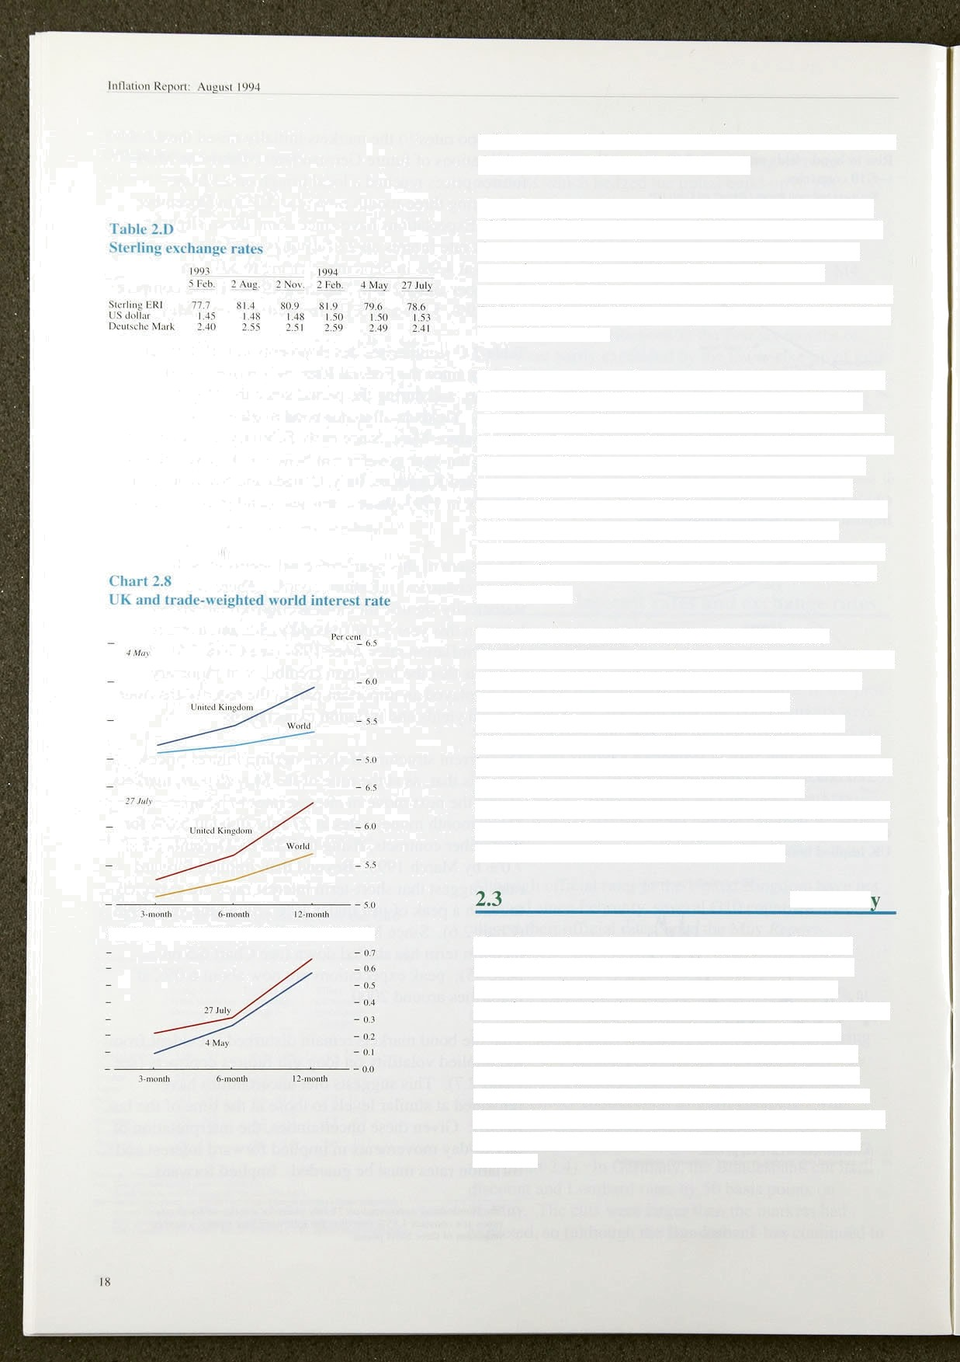

The signals from the monetary aggregates diverged slightly for most of the second quarter, with narrow money continuing to accelerate and broad money growing more slowly. But narrow money began to slow down in June and July. The deceleration in broad money seems to be related to personal behaviour, as individuals adjust their bank deposits. The financial markets have remained turbulent with **concerns** about the world recovery and the weakening dollar. Recently, however, European markets appear to have begun to stabilise.

 

Table 3.A

Eiipendlture components of GDP at constant 1990

**prices**



|  |  |  |  |  |
| --- | --- | --- | --- | --- |
|  | t993. Q-4 | 1994 Q.1 | l993'Q4 | l99d Ql |
| Consumer' expenditure | ) .J | 0•6. | 3.2 | 3.3 |
| Puñlic:co'nsumption | •0.3 | 0.6 | I .0 | 2.5 |
| investment | 2'.5 | 2.I | I .3 | 3..2 |
| Ijomestic!demand | 1.3 | 0.4 | 2.8 | 3.0 |
| *6 xg* art *s* | 0.6 | 2.3 | 3.I | 4.4 |
| Tolat final demand | I.I | 0.8 | 2.9 | 8 8 |
| Imports | '2:7 | 0.R | 3.3 | 4.I |
| GDP:at'Iactdr:cost | 08 | 0.? | 2.6 | 2:9 |

Chart 3.1

GDP, non-oil GDP and real national

**disposable** in€ome (RNDt) growth



— — 2





Taiile 3iB

**Contributions** ti›1the **increase In .GDP**



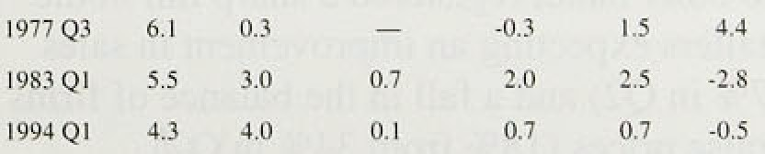

8

Non North Sea output rose by 0.69» during the first quarter and by 2.3&o in the year to the first quarter. Tota) output rose by 0.7% in the quarter and 2.99a over the

year. According to the preliminary estimate. growth in non North Sea output rose by 0.8% in the second quarter and by 2.7% in the year to the second quarter.

A recent survey by HM Treasury of lorry outside forecasters revealed a median projected growth rate of GDP of 2.89 in 1994 and 2.79 in 1995—slightly above trend. Most forecasters have revised their projections upwards from a few months ago. However, the distribution of forecasts is widely spread and the underlying interest rate assumptions also range widely, from 4.29c to 6.1 % in 1994 and from 4.59o to 10.0' c in 1995.

## 3.1 Demand

Domestic demand rose by 0.4% in the first quarter; compared with a year earlier, it was up by 3.0%. with both consumers’ expenditure and investment increasing by over 3% (Table 3.A). A £0.5 billion rise in earnings on overseas direct investment in the first quarter contributed to real gross national disposable income

.rising by 4.9% on a year earlier (Chart 3.1).

Table 3.B compares the shape of present recovery with the.last two recoveries. It shows that, whereas recovery was driven by net external trade in the 1970s and by a combination of consumption, investment and stockbuilding in the 1980s, the present recovery has been dominated by consumption, following a relatively large fall in consumption during the last recession.

Sectoral financial balances tell a similar story. **Chart** 3.2 illustrates! the financial correction underway in the corporate sector, where high profitability and low investment have led to an improved financial position

.(see below). The personal sector was reducing its rate

.of saving until the beginning of this year, so that its surplusideciined until 1993 Q4 (Chart 3.3). Chart 3.3

#### *.*fl*ea* illustrates the rise in. the.puñ!ie sector deficit during





sector deficit in the years ahead (the PSBR is projected to fall below 3% by 1996/97 and be in broad balance by 1998/99).

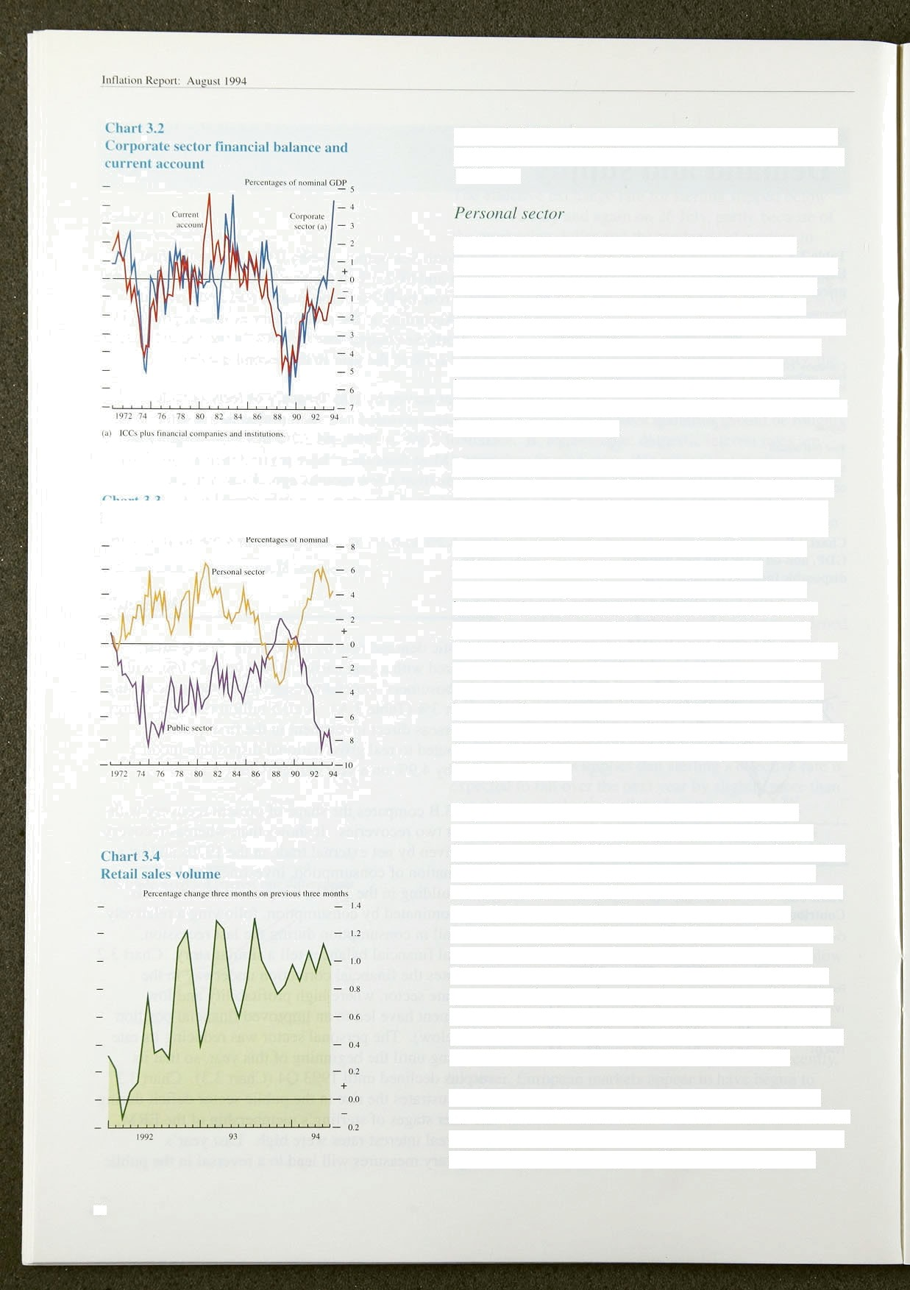

Consumers’ expenditure rose by 0.6% in the first quarter, to a level 3.5% higher than a year earlier. Real personal disposable income also rose strongly in the quarter (by 0.7%), largely reflecting a 2.1% rise in nominal earnings from employment (l.99c in real terms, deflated by the TPI). The saving ratio therefore rose very slightly, following two quarterly falls. An important part of this rise was pre-payment of fuel bills in advance of April’s imposition of VAT, which the **CSO** has classified as saving.

The growth of retail sales has been sustained in spite of April’s tax increases, which were borne entirely by the personal sector. Retail sales rose slightly in June, and there continued to be robust underlying growth (1.0% comparing the last three months with three months earlier—see Chart 3.4). The composition of consumption expenditure also suggests that the tax increases have not caused consumers to retrench. In particular. purchases of durables have held up well; sales of household goods were 5.3% higher in the three months to June than in the same period a year earlier (compared with 3.9% for total retail sales). Car sales have also been strong, rising 16.1% in the year to the first quarter. Department of Transport figures show that the number of cars registered fell in April but rebounded in May and June.

Experience suggests that the impact of changes in income on consumption will take some time to feed through, so it is still likely to be some months before the full effect of the tax changes becomes clear. Survey evidence on the outlook for consumer demand is mixed. The **CBI** survey of distributive trades shows that retailers were pleasantly surprised by sales in June and eKpect a further improvement in July. The **Dun** and Bradstreet survey of business expectations in the third quarter, on the other hand, registered a sharp fall in the **balance** of retailers expecting an improvement in sales (46% from 57% in Q2) and a fall in the balance of firms expecting to raise prices (l 89c from 34% in Q2).

The housing market appears subdued, as a result of a combination of factors: the rise in fixed interest rates for mortgages; the reduction in mortgage interest tax relief; and the impact of more general tax rises on personal

20



**.Chart 3.5**

**Housing market activity**

 





t right•hand Yeah)

**:129-**





##### disposable income. According to the Halifax Building

Society’s index; house prices have fallen slightly over



##### l.5&c higher than in June 1993 (Chart 3.5). The Halifax has revised down its forecast for house price rises to the end of this year from 59c to 2%—3%. .But house prices have started to rise in the South East, the area which was most affected by negative equity (prices rose by 2.2% in the year to the second quarter, with prices .for first-time buyers rising by 3.2To). The Nationwide’s index has displayed rather different monthly movements: it has risen 1.2&r over the past six months, but only 1.0&r since

June 1993.

Particulars delivered a measure of activity in the housing market—have fallen from 112,000 in January to 106,000 in June, although they remain 7.1% higher than in June 1993. Although houses seem relatively ’affordable’ (as measured by the ratio of house prices to earnings), the housing market seems subdued at present. However. land prices, tender prices and the price of construction material have all risen (albeit from a very low base—see the box on page 22 for details on land prices) and the figure for housing completions in May was the highest for over two and a half years, suggesting that builders may have been anticipating higher demand.

The current flatness of the housing market. while lowering the expected future cost of housing for the personal sector, will dampen the growth of personal sector wealth and may act as a depressing influence on consumption. At the end of 1992, 399c of total gross personal sector wealth consisted of residential property, 7% of bonds and equiñes, and 269n of claims on life assurance and pension funds. Bond and equity prices have fallen by around 10% since the start of the year, which implies a.fall of approximately 39c in gross personal,sector wealth, taking account of the direct impact on wealth and the indirect effect through life assurance and pension funds. Wealth changes, like tax changes, may feed through to consumption only with a lag. The indirect tax increases, both those already implemented and those to be implemented next year, and these wea1th,effects are perhaps the main sources of uncertainty surrounding the outlook for consumer spen‹iing..



##### Corporate.fin .ances:are rocking. increasingly strong: profitabñity,:and, tained enrn:ngs!were liigh i:n°1994 Q1





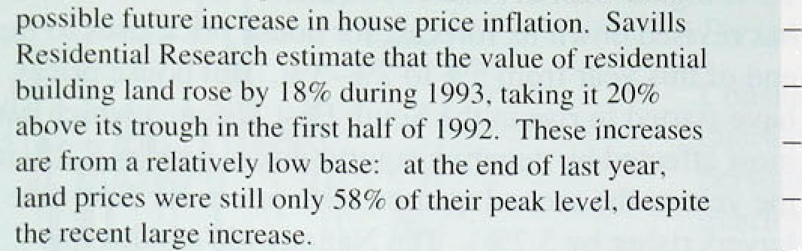

La*tpiic°,

 



supply: is restricted. either physically or by planning „,

re ulatinris.







.611

Charl B



The price iil land'° • re1ali›'e t‹i the price of houses *'



Reports .frcim:the Valuati'on Office .and elsewhere infiicaie —

!that‹ builder:sShave started ‹to restock land-banks: which

! mad..been run down..to vetj low:levels.. This rejects —





lVSl °N? .R5 B4 #S. :86. 83 .8B'. 8O. OU. P !92 9 !

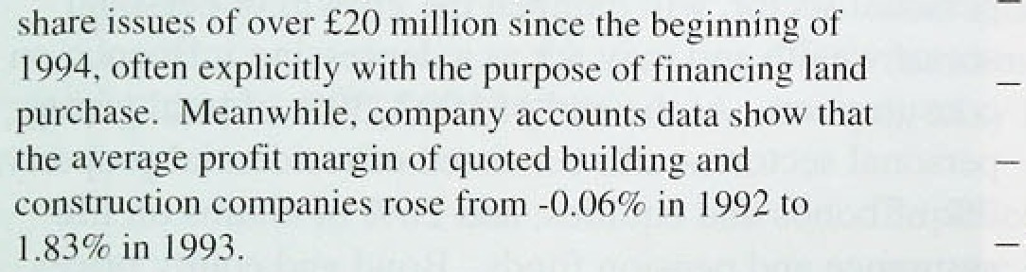

:’l)

0s,..an ri:ng the

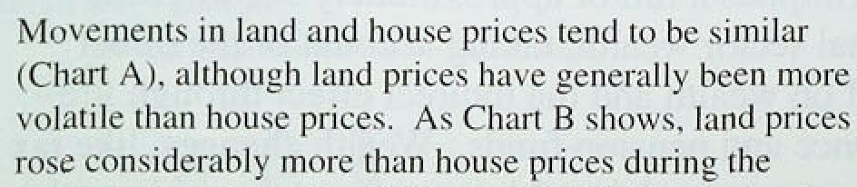

recession,.a pattern. which repeats’:previous cycles.

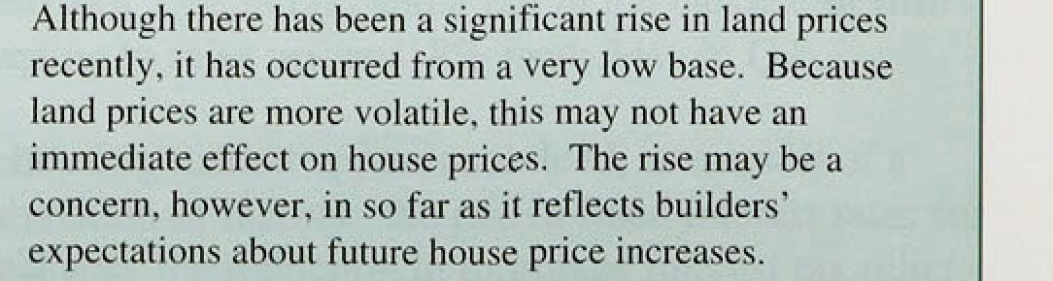Causality betw.een !land and .house prices coulii. run'in both.dire°clions. . It is .likely that builders.' demand for lanfi. is iiiiveri by expectations about future ñnnditions in the

..housing market,..which.swill..both.iffect.and:be.affected by

.culprit house.prices...Land price rises.will tend to impinge first on the price of new houses,. before‹filtering through the rest.of tlte housing.market.. .In.practice; it.is likely that iiuilders wil!l.try to recoup sonic of.their higñer'

prices .of .new and old,houses.tend to:riore.very closely

tgo ether ' '





(see Chart 3.6). This reflected both productivity gains and greater cost control (see Section 5). The company sector as a whole has used its financial resources to repay large amounts of debt.

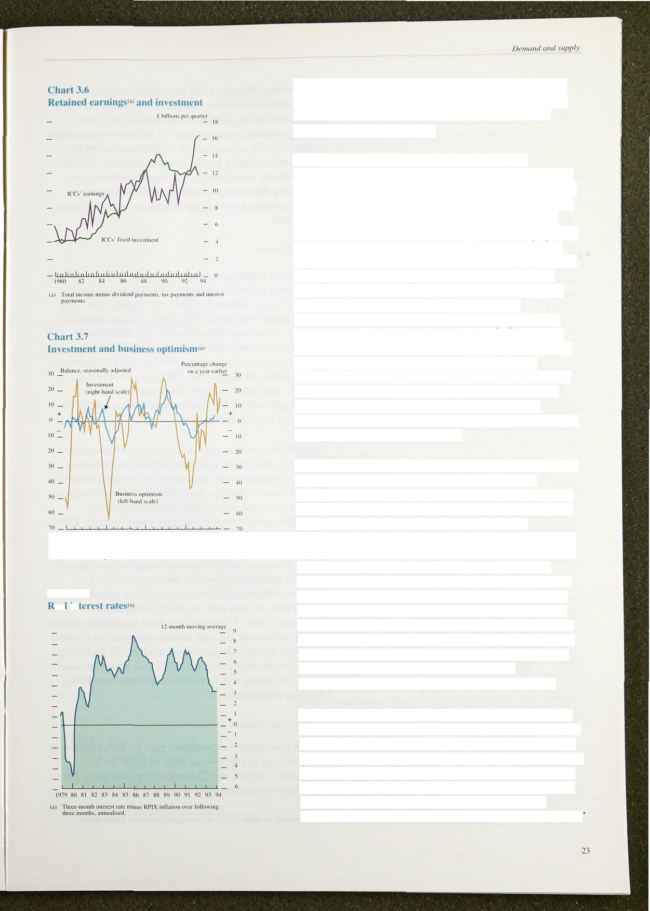

There have been tentative signs of a pick-up in investment, which rose by 2.1 % during the first quarter, leaving it 3.2% higher than a year earlier. The output of ’investment goods gained strength in recent months, and was 4.9% higher in May than at the end of 1993 (the output of consumption goods rose by only 1.6% over the same period). And the measure of business optimism from the CBI survey—which tends to have a reasonably close relationship with actual investment—has been increasing (see Chart 3.7). The rise in investment has

been patchy, however, with investment in the

manufacturing sector falling quite sharply in the first quarter (by 2.7%). Indeed. the increase in investment during the first quarter was more than accounted for by general government. The balance of investment intentions from the CBI survey has turned positive, but remains rather weak, with uncertainty about demand regaining its position as the main reason cited by respondents for not investing, with inadequate net return the second most important factor.

There are a number of reasons why investment has been relatively slow to recover, even though business optimism is growing and corporate finances are strong. First, a number of firms do not appear to have adjusted their investment strategies to a lower inflation environment (this issue is considered in an article on pages 25a of the August *Bulletin* and was the subject of a recent survey by the CBI). Second, the recent financial market turbulence will have made equity and bond issuance more expensive than during the winter. Moreover, as inflation has fallen during the course of this year, real short-term interest rates have risen: they are roughly at the same level now as in the early 1980s (see Chart 3.8). Finally, it may be that firms continue to feel dissatisfied with their levels of debt, notwithstanding recent heavy repayments to banks.

The stockbuilding component of **GDP** was negative in the first quarter (- £0.4 billion), though this was entirely accounted for by the quarterly adjustment factor which is applied to bring the income and expenditure measures of GDP into line with the output measure. Stocks rose by fi0.3 billion in the manufacturing sector, the second successive quarterly rise. Stocks were flat in the distributive sector as a whole. with a rise in wholesalers

intJ‹itic•n ReI'‹›rt* AuE'ust 1004 _

stocks being offset by a fall in retailer’ stocks. From a longer-term perspective, stockbuilding would normally be expected to be positive at this stage in the cycle (average quarterly rises of.over £1 billion were recorded in the 1977—78 period, and of £0.6 billion in 1983), though the quarterly profile is highly volatile. Stocks have recently varied much less than in earlier cycles, suggesting that improvements in stock-management techniques may have helped to mitigate volatility from this source.





IJ9Lr'-100

*E.y(th nul tr‹ide*

The United Kingdom’s external trade deficit narrowed to

£3.2 billion in the first quarter, following a (revised) deficit of £13.7 billion for 1993 as a whole. The

##### " improvement was largely the result of a rise in the oil

„q surplus: excluding oil and erratics, the deficit was

£4.4 billion, broadly similar to its quarterly average

* during last year. As a consequence of the CSO’s recent

##### quality audit, the figures for 1993 have been revised

„ slightly: the deficit with the .European Union was revised.upwards by f0.3 billion and the large deficit in December was revised down.

The outlook for the trade .balance reflects movements in demand in the United Kingdom relative to its trading partners, together with movements in competitiveness. Chart 3.9 shows that the trade deficit narrowed slightly over the past year, as the benefits from increased competitiveness following sterling's exit.from the ERM offset the increase in UK demand relative to its nading partners. However, the continuing recovery in the United Kingdom is likely at some.stage to be reflected in higher demand for imports and in greater lcost pressures which could have some adverse impact on the trade deficit, at least.until recovery strengthens

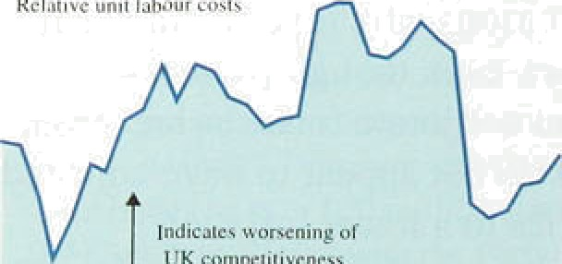

Re l air ve unit flour cost s

— ION

' 8S

elsewhere. Chart 3.9 showsl that there has already.been a

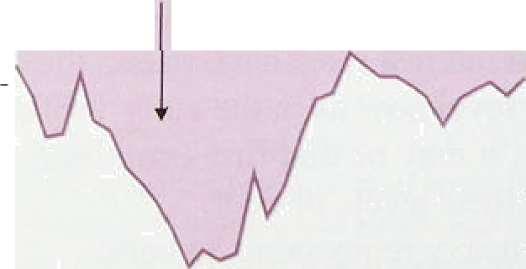

* z



' countries. Much will depend.on .whether the high levels

* + .of investment during the late 1980s ,and impfOVed.labour

, market flexibility will’ have been sufficient t0 enhance

i• >

UK trade performance,(!)

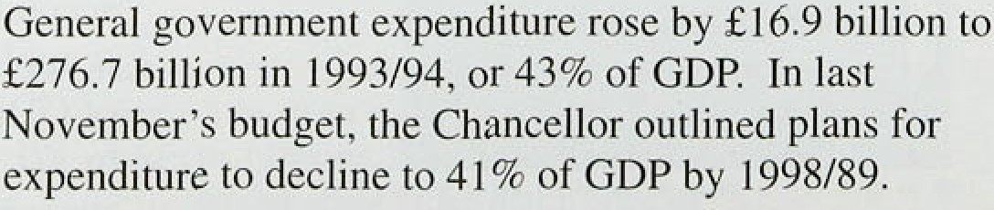

*D,emand* and *supp'py*

Government expenditure made a small positive contribution to growth over the first quarter, and contributed around half a percentage point to growth in the.year to the first quarter. Capital expenditure by



general government made a substantial positive contribution to first-quarter growth (almost 1 '/• percentage points), but contributed only around a quarter

 of a percentage point in the year to the first quarter.

— — 5.0

— — 4.5

— , , — 3.*



tH I nclud es' unemployment benefit. incomt support had fzmily t'crrefii.



Given the sharp .cyclical movements that have occurred over the last few years. it is interesting to examine the way in which government expenditure has evolved.

Chart 3.10 shows cyclical social security payments, which are the most cyclically- sensitive elements of general government expenditure. There was a sharp rise in expenditure in the early stages of the recession, but the experience of the 1980s suggests a substantial reduction is in prospect for the coming years. This measure of cyclical social security payments accounts for approximately 10% of total government expenditure.

## 2 S

Survey evidence suggests that capacity usage is increasing across much of the economy. In the July CBI survey of manufacturers, 54% of firms say they are working below capacity, down from 59% in the April survey; this compares with 67&a at the same stage in the previous recovery. The higher reported capacity utilisation in this recovery might reflect more intensive use of firms’ labour—less labour hoarding—assuming that some firms take labour as well as capital into account i.n assessing their capacity, But only 38% of firms say that their fixed capacity is more than adequate, compared with 50% in the previous recovery. The British Chambers of Commerce survey, which covers both manufacturing and service sector firms, also shows a rise in capacity usage, but the survey has not been conducted for long enough to permit a comparison with the previous cycle. In manufacturing, 29'f• of firms now report themselves to be working at close to full capacity, up from 25&« in the first quarter; and 22% of service sector firms report themselves to be at close to full capacity, up from 20a in the first quarter. Similarly, for the consmiction sector, the Building Employers’

Confe;ieration survey reports a sharp rise .in firms operating. close to capacity, to 36% in the second quarter.

Measuring how far the economy as a whole is from full capacity or potential.:output is: a difficult task, and depends!oniassumpti:ons.about the.supply of labour and



Inflation Repon: August 1994

capital, and about the efficiency with which labour and capital are combined in the production process. For none of the variables is it straightforward to distinguish trend from cyclical components: for example, capital scrapping is likely to .increase in recessions, and the supply of labour will be influenced by cyclical as well as structural developments. There is also an important distinction .between short-run capacity and potential output in the longer run, when the supply of factors of production .has had time to adjust to demand. Too rapid a move towards long-run potential output is likely to be inflationary.

Perhaps the most straightforward approach to estimating an output gap is to begin with a production function relating output to labour and capital inputs and the efficiency with which these inputs are utilised. Over the past 30 years, output has tended to grow around l'/4% a year faster than implied by the growth of measured labour and capital inputs alone.( Since 1990, the labour force has fallen and growth in the capital stock has slowed. This wvll have tended to reduce potential supply, implying that the output gap .is smaller than it would otherwise have been.

However, there are two other factors whlch need to be taken into account with respect to measured labour and capital inputs. First, several studies have suggested that the measured capital stock is overesltimated, as the asset lives assumed in the calculation may be too long, with insufficient allowance made for scrapping. If ,the capital stock is overestimated consistently throughout the cycle, then this will have no effect on the estimate of the .output gap derived from the production function approach. But

.if—as seems likely—there is accelerated scrapping during recessions, the:overestimate of the capital stock increases.

Second, what matters for potential output is not the current labour force, but the long-run potential labour force and.the natural.rate of!unemp1oyment. The long-run potentiallabour force .will.depend:on factors.

such as participation in education, early retirement and the extent of pan-time workiny. Although these eleménts appear, to have increased in the l990s, this. is probably due in large part.to the.decl!ine!in the demand for labour front its peak„.father than an.y.long-teriiJ

.developmental in:supply..,. The nat rat..rate.of





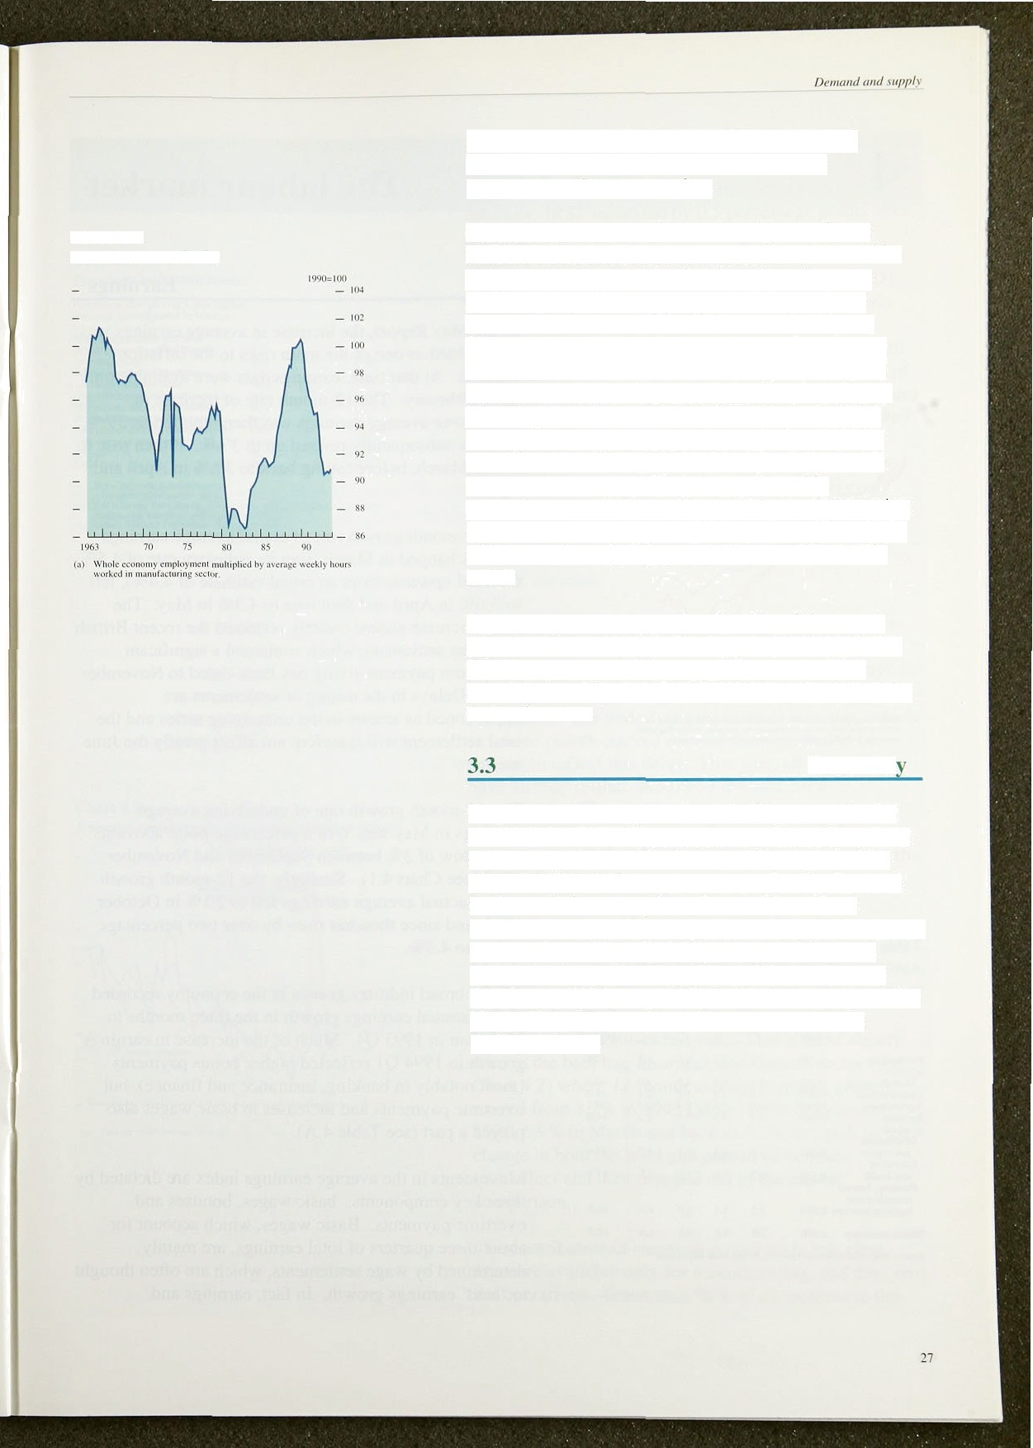

**Chart 3.1** l

**Total hours worked'°'**

unemployment will be influenced by the level of frictional unemployment and the institutional arrangements for wage-setting.

Chart 3.1 I shows an estimate of total person-hours worked. If the level of hours worked in 1990 could be regarded as an appropriate benchmark for long-run labour input. then the current output gap would be estimated to be around 6%. This seems too high— potential output iS likely to be lower coming out of a recession because of unrecorded scrapping of capital stock and the erosion of the skills of the unemployed. There is particular uncertainty about the level of the natural rate of unemployment—the choice of 1990’s actual level is arbitrary. In fact, the chart shows that there has been a generally downward trend in

person-hours worked over the past 30 years, suggesting the long-run level may be well below the 1990 peak. in which case the output gap would be correspondingly lower.

Inflation appears to respond to the size of the output gap, the rate at which actual output is growing relative to its long-run potential rate. and the rate at which output is growing relative to the growth rate of capacity in the short run.

## Summar

Output continues to grow above its long-run potential growth rate. Consumption appears to be holding up. in spite of negative wealth effects and the impact of tax rises on personal disposable income. Recent financial market turbulence may have deterred firms from investing in the short term, but the underlying factors are encouraging, with profitability strong and business optimism recovering. The trade position is likely to deteriorate slightly. especially in the short run. given the United Kingdom’s cyclical position relative to its

trading partners.

4



Vh.rt41

’Gndwlin rninqgr‹m'th•



i99I 92 93 94

## E n s

In the May *Report,* the increase in average earnings was highlighted as one of the main risks to the inflation outlook. At that time, earnings data were available only up to February, The 12-month rate of increase in *underlying* average earnings was then reported as .3'lit,

, but was subsequently revised up to .3 J‹9a. It.then rose to 4% in March, fiefore falling back.! to 3’/•%. in April and May.

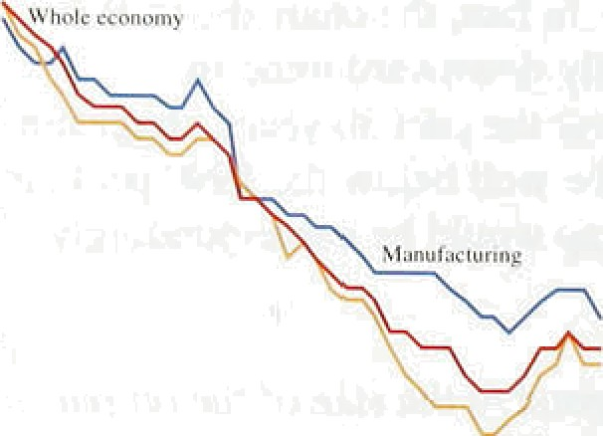

,

##### The 12-month growth rate of nrmn/ average earnings was unchanged in.March from its February rate of 4.5% (revised upwards from an initial estimate of 4.4&r), fell to 3.69c in April and then rose to 4.3& in May. The latter increase almost entirely reflected,the recent British Coal paylsettlement, which contained a significant

lump-sum payment giving pay back-dated to November 1993. Delays in the timing of settlements are apportioned as, arrears in the underlying series and the coal settlement will therefore not affect greatly the June measure.



Table I.A

Average earnings gr‹›wth (selected series)

Year-on-year pcrcenuigc change

Employ- f994 Change



e hi i993 04

Production 0.289 4.7 5.1 4:5 6.8 +3:8



Manufacturing 0.263 3.9 4.7 4.7 4;,0 +.0,)

Construction 0,055 2.0 1.3 1.5 2.4. * I.3'

Agriculture 0.OJ? 4.5 7.6 2.4 2.3 -0.I

Serricea 0.639 4.1 4.3. 3.3 3.2 +1.0.

***nf* 'hich:**

**Disoibution**

and repairs 0. 67 3.8 4:4 4: I 4:2' ef.6.:

£ducaiion



The 12-month growth rate of underlying average earnings in May was '/• of a percentage point above its recent low of 3% between Septer ber and.November 1993 .(see Chart 4.1). Similarly, the .12-month growth rate of actual average earnings fell to 2.1 to in October 1993, and since then has risen by over tivo .percentage points to 4.3&.

##### All the broad industry groups in the economy recorded



May than in 1993 .Q4. Much of the increase in.earnings growth in 1994 Ql reflected higher bonus paymentsl (most.notably:in banking, insurance and finance): but overtime payñients and increases ih fiasic wages also played a part (see Table 4:A).

insumn e and

business scnvicos 0.093

3.2.

5.7

'' +' 6 Movements in the average earnings indéx.arq,ñictated by

##### , 2 4, +, , ,three key components. basie waged, bonuses and

overtiine:payñients. Basic wagés, which account for

 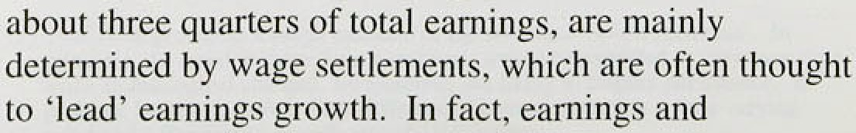



*The:labour marL.. .t*

Table:.dtB

**Earnings and settlements**





**.LRD.ibydj**







June 3.2 (3.2)

May 3-3.9 t2—2.9)

Mny. 2;.5 (2.3)

settlements data tend to have coincident turning-points, as shown in the August 1993 *Inftation Report.* Median pay settlements. as reported by Industrial Relations Services (IRS), increased by 0.5 percentage points after the August to December 1993 trough, to 2.59 in January, where they have remained since (see

Table 4.B). The Labour Research Department (LRD)

report a similar pattern. Their measure of settlements rose by 0.5 percentage points to 2.5% between December and February, and remained at this rate until May. The Income Data Service's (IDS) modal range of settlements rose in May to 3%—3.9%, from 29c—2.9% in April,.having been unchanged since January. This May range is, however, based on a smaller sample than in

##### previous months. The CBI also report settlements

rising. Between the three months ending in February and the three months ending in May, they found settlements to have risen by 0.2 percentage points to 2.7% fn manufacturing, and by 0.5 percentage points to 3.2&a in services.

Chart 4.2

**Average Earnings giowth in the service** sector‹•1

*.Percentage changes on'a year carl r 4

_ ’Backing, ns toe., insurenm _ \g

— 10



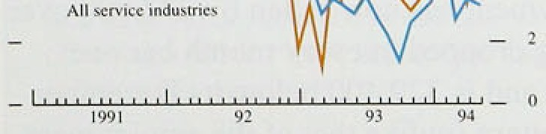

Major public sector groups, including doctors, dentists and teachers, have pay settlement dates in April. In previous years, these groups have experienced delays in reaching an agreement and have then had their awards back-dated. The underlying measure of earnings, which is a .three-month centred moving average, had to be revised to reflect this delay. This year, all these groups

.have already settled, at 3.0%, 3.09c and 2.9% respectively. Therefore April’s and May’s earnings figures are a more accurate reflection of underlying earnings growth than has been the case previously at this ume of the year.

##### Larger-than-normal bonus payments played a prominent role in the increase in earnings growth in February and March, especially in the services sector. There .were two other important influences: some bonuses were paid a month earlier than usual; and many firms paid

below-average bonuses last year. This is most clearly seen in the banking, insurance.and finance sector (see Chart 4.2) where 12-month average earnings growth. moved .from 3:2& in 1.993 Q4 to .12.8% in February



chañge in hoth’the level and pattern of bonuses

The.contribution'of overtime.payments!is less clear.



1nflati‹›n Rep‹›n: AHgust Nu4

Chart I..1

C“hanges in unerrtploymertt I t• **mat Britain onlY)**



sector. Between .1993: Q4 and 1994 Ql, overtime hours rose by around 3.5% which, according to the Employment Department, accounted for half the rise in earnings .growth in manufacturing.

## 4 2 E 1 ent

.Employment according to the ‘workforce in. employment’ measure, base‹i on surveys of employers, grew by 122,000.between .1593 Q.1 and 1993 .Q4, before

"' falling .by 73,000 in 1994 Q1 (see the box on page 31).

More timely employment data are available only for tlie ' manufacturing industry. This sector’s employment has

declined since 1978, on .average by over 180,000 a yet. Manufacturing employment fell by 12,000 between December 1993 and March this year, but increased by

i 5,000 in April and May, indicating a recent increase in labour demand, against the trend in this sector.

Vacancies data also indi.cate that lañour!demanfi in the whole economy increased in April and May, The (seasonally .adjusted) stock of .unfilled vacancies at Job Centres has increased in every month this year. Between December 1993 and March of this year, vacancies rose by 700, but by June they were a further t1,300 higher.

**Table I.C**

**Comparison of unemplo2’ment measures**

Thousands: seuso›rnf/¿ *udjiuied*

Labour Force.Survey (GB) Clairñanl c'ount (GB)

Tounl un- Ch0n e 'on Currtul- Tolal un- Change. on:Cumnl- employ- previous gt ve employ- previous alive ments periods change merii period :cIiaitge

|  |  |  |  |  |  |
| --- | --- | --- | --- | --- | --- |
| Spr. 90 | I.90b | -I iD' | far. 5'0 | 1:301 | -z41 |
| Spr. 9.i | 2,334 | +434' | Mar. 9t | 2,063 | +362 |
| Sum. 92 | 2.756 | +?'i | June 92 | 2,664 | *83 |
| Wln. 9’2 | 2,909 | +9l | D•c. 92 | 2.859 | +9l. |
| Sum. 93 | 2,854 | + l6 | -Sfi. . June:93 | 2,814 | -!4 |
| Win. 93 | 2,729 | -80 | -180 D•c. 93 | 2,6d3 | -8.1 |







-31

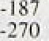

It is not unusual to receive contradiétory signals from labour market .indicators as the market moves from recession into recovery. At a turning-point, not all sectors will be moving in the same direction. This appears to have been the.case in the first quarter of this year. The signs are that, in 1994 Q2, labour,demand has increased.

4.3 Unneeimii



o



en

Unemployment continues:to fall: Claimant. unemployment was..2.fi4 million.in June (9.49• of.the workforce), its 1fiwest.level sincle February 1992.

Claimant unem



the last year, having dropped"ifi every.month! b.ar'one

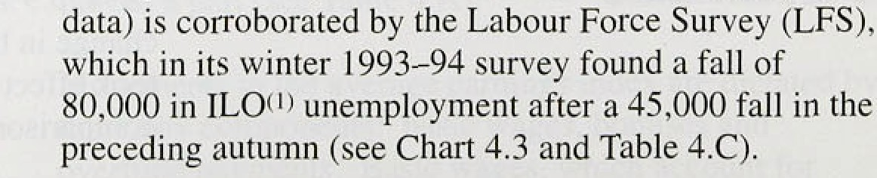

(I) The-l^tcrnatio.o’aI @bour›,Otgan1s#gon.(1L:O) intottaiio!al Standard





# .Employment:: .recent developments and data”revisions

Data revisions have..altered the estimated changes in employment in the.last reeéssion. ' It: is now cleâr tJiat.

C’ h*r l II

t’lianges i» end plos ltltllt



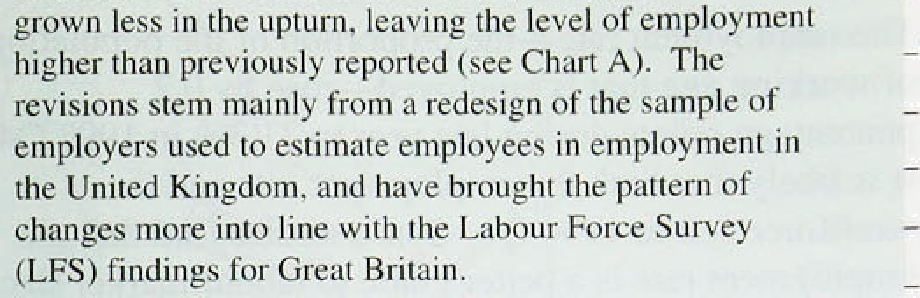



" quarrel for the United Kingdom ; the LFS is coiidueted for Great Britain only in the .last month of:one quarter and first two of the next; eg December, January and.February

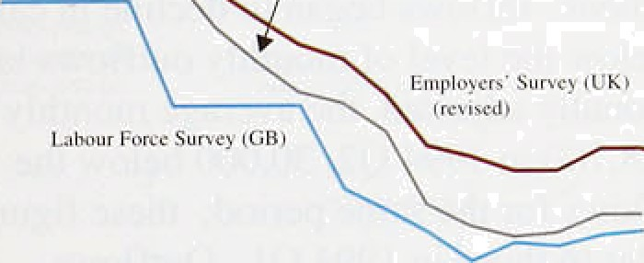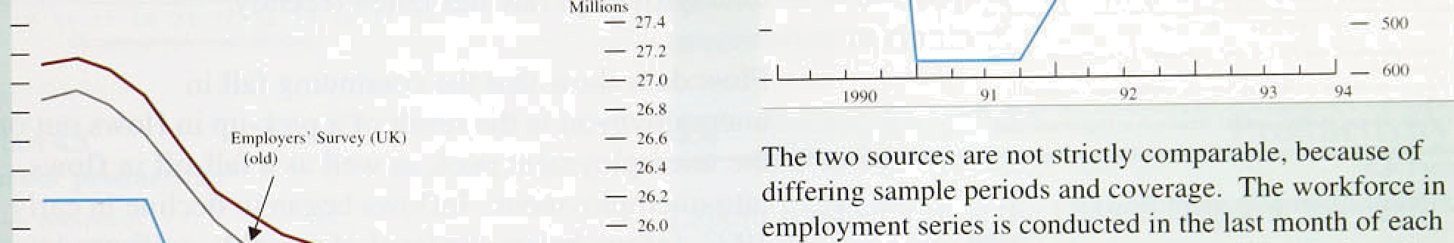

•i.o for the winter LFS. The two measures have previously

— *• ^ moved broadly together, with the same peaks and

" * troughs, thoup•h their quarter-to-quarter moveinents hAVâ differed (see the table). A better comparison of ihe behaviour of the two employment series is the cumulative



The estimated faJl ifi erriploy,iiient between June 1.990

and March 1993‘has ,been.revised down,by 139.000 from 2.0ñ6 millio'n,.aii‹i.!the 'subsequent. rise to December 1993 by 30,000 to 104,000,:leayin% the December level 327,00i0.tiigher. i‹Much of the itpward revision stems from i inériases in tlte’estiinatés ofi self-employment. Among the einploye‹i, .the extent of the svwitch from'full to

part-tirrie working has ñeen rev ised,.down. The changes

.change in employment in the four quarters. to!.enfi- 1993.. The workforce in .employment :measure :inc reased.by 29,000 during this period, while the LFS noted an. increase of 149,000.

*Gvm y•o* risen ‹if empl‹›y 

 **EmpoyowhuWdtGB$**

are .most!marked.ifi 1992.Q3



Tool Change on Cumul-

fi '' ork force in (Change on

employ- prr›'ious aiix'e empl oymeni prc''i on*

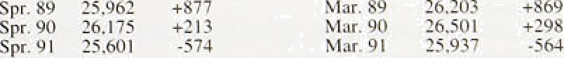m«n‹ amid _ change {›criod «hangs

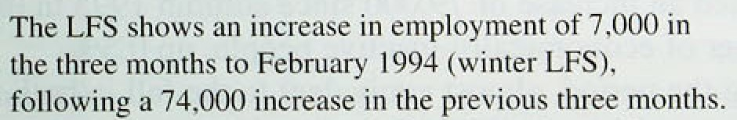

e for



Suril. 92 25,021 -126 June 92 ?ñ ?O3 -j l tl

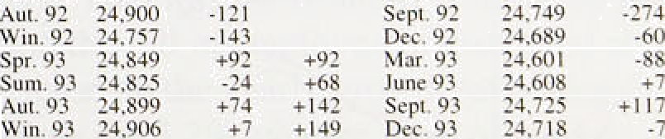

recovery. A rise of 36,000 in full-iime ork; inoré..than.:. offsetting.a fall.of 17,000 ia part-time employment; supports this.?:iew.*”

Botli the **measutes** iiriply that.liboiir'demând ihcreas‹id’.



-88

**These** findings .are contradicted by Hie ‘wprMorce in employmeñt’ series for the United:Kingdom; which fell by 6,000 in 1993 Q4 (the period, most comparable with

.the winter LPS), having increased by 122,000 in 1993 Q3. :Tbis **series,** though more erratic.than the **LF5, .is more tiinely;** during 1994 Q1 it fell by 73,000, inilicating **thjtt,4ey.recovery in.mploymept** is.weak at be8t.

*over* 1993, but offer contradictory’Signals.about l994tQ1.. Manufacturing employment..the only séctor for which more tiiñely diita are.available, increased .by 5,000 in.

April ânfi May, having fallen by 12,000 in the previoiis three months. Manufacturing accounts for only 20.3,d of total **employment;** nonetheless tiiis suggests that labour deinand has increUed ret›i tly: . '



Intl:twit n Rcpurt: Au*ust I0'?4

Regiona:! unemployment rates; which converged du!ri:ng the recent recession, are now falling:in .unisoñ. .Since March 1.994, the .unemployment:rate has:fallen. by at



' least 0.1 of a percentage..point.in every regi:›n.



,

* + _ , The employment rate—the propottion of‘ttie.!population

_ of working age. that is. employed—rose by 0,2

percentage points.during last year to 71.3% in. .1993 .Q4:

* It is likely that bloth the employment.rate and the

* + workforce fell in 1994 Q1. Some: studies **fln‹i** that the



”

— employment rate is a better gtiide to labour rñarket.slack than the unemployment rate. As Chart.4.4 shows.; the employment rate has not risen as fast.as the

_ unemployment rate has fallen recently.



Flow data show that the continuing fall in unemployment is the.result of a pick-up .in flows out of the unemployment pool, as well as a .fall-off in flows

.into unemployment. Inflows began to decliiie. in early 1952, falling ñelow the level of monthly outflows later

, , that year. Seasonal.ly.adjusted, the!.average monthly

*“ inflows was 328,700. in 1994 Q2, 30,000 belo,w the

##### ' .number of outflows for thg same period; these figures

’“ were very similar to those in 1994 Ql. .oiitflows

— ' continued to grow until October 1593, since when they

##### - ‹ have declined (see Chan 4.5). .Outflows as a percentage

_ , , of the.unemployment:total an approximation to the'exit

_ q .rate from the unemployment pool have increased since the start of the. year. Similarly,: inflows.:1as.a perclentage of the population—an approx:imation:to:the entry, rate—

 have declined..

Chan ‹.r Those.people who left.the.!claiinant count in f994 ,Q1 did

l£inploviuenl and unempltiviiicnt grow th ar‹›uiid not.appear to.enter employmeiit., The winter 1993.LFS

i eccssi‹in.S'" .reported an .increase of 79,000 since autumn 1993 in the

I974=7fi Item ssion Nrougfi = I975 Obj

Al nemployment i dotltd l inc 4



Trough of recession = ion rro i6c —

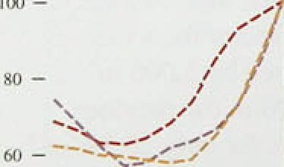

140 -

’* '^

._ „

during thg. period, almost eqpivalent to the: fâll in.both unemployment (.83i800) in:tit.is period.

It. i:s.not:u:fius0al for.employment:.to Continue to falt in the **iirst.two,** years of a reéo.vefy (as can be-seen in Chart,4.6); .w!hat is. unusual is, for uneriiployment to fall. so sooni after. a trough in output. This is.,the first.time in ’’.20.years that.both clai!mant unemployment and the



.workforce in employment series have fallen

. simultaneously.

What :are.the:1ike!y cont uences of these movements for eami.rigs? .Fal:1s: in unemployment are!noñnally assum.ed..to reilue.e the dow.nward pressiires on wages.







**Chart 4.7**

**Nnriiinal wage lnflstlon end unemployment**

l2•mondi,perocninge risc in nominal wagm







Workers feel more secure in their jobs arid firms mfi feel the need to increase wages to attract labour as it becomes increasingly scarce. However, the

Responsiveness of wages to unemployment has been low

1. the United Kingdom. In the mid to late 1980s, for instance, unemployment fell by over a million, but nominal wage .inflation rose by less than three perelentage points. Similarly from 1989 until 1992, unemployment rose by over a million and nominal wage inflation fell by less than three percentage points (see Chart 4.7). With such sizable movements in unemployment having generated so little reaction in

##### wage inflation in the recent past, it is unlikely that the

* + recent fall in unemployment will lead to a substantial acceleration of earnings.



**Chart 4.8**

**Labour produellvity**





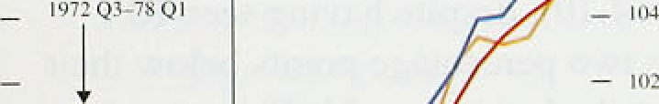







**Whole econozoy:prpductIvity and unit wage costs**









##### 4 t V t

Labour productivity in the United Kingdom has been strongly procyclical. Over the recent recession and subsequent upturn, labour productivity first fell and then increased strongly. The pattern in duration, timing and relative scale was much as it had been in previous episodes (see Chart 4.8). There have been slight differences recently. In the previous two cycles. productivity continued to increase in the last stages of

.GDP expansion and then fell quite sharply a year after the peak. In the current cycle. productivity grew less rapidly in the final stages of GDP growth, recovered faster after output had begun to fall, and increased at a similar rate as in previous cycles during the early recovery phase. Otherwise the recent recovery remains very similar to those of the 1970s and early 1980s.

Whole economy productivity growth rose in 1994 Q1, by 0.99» on the quarter and 2.6&r on a year earlier (see Chart 4.9). This was the result of continuing growth in output and the fall in employment discussed above. This

is an increase on the yearly growth rates seen in 1993 Q4 but is below the 3.2&r average level of labour productivity growth in 1993.

#### Mor.e timely data from the manufacturing sector confirm the continuing growth in labour productivity.

Manufacturing output per head grew by 2.0&o in the first quarter, 2.6% up on the same period in 1993, 0.4 percentage poiñts higher than th 1993 Q4.

#### Manufacturing productivity has since grown by 0.8% in the o.months to May, the slight fall in the gmwth rate Kflecñng the increase in employment in this sector.

Infi0tiori Return: August 19.04







tJuquil E inpl uy• Cabour Wam'iugx per Uoit wage

Iu i SYhnJc unomy



tbl MaauFactoring industry

Whole economy unit wage costs.rose in 1994 Ql, .to a level I.,9&o higher than a year earlier, having been almost unchanged throughout 1993 (see Table 4.D). Despite this rise, the four-quarrel growth rate of unit wage costs remained more than five percentage points below the

.average level .for the 1990s.

4.5 Ex **e**e**ctatio**o**i**n**is**

Wage bargainers make nominal wage agreements bearing in mind the likely real-wage outcome. To the extent that future expected real wages influence pay bargaining, it is necessary to understand the bargainers' expectations of future price inflation to assess the actual

nominal outcome. As noted in previous *Inflati.on*

t99 I -5.?' •S.t\

1902 -0.6 •4, 2 4.4

7.b *Reports,* although .monetary policy will not.validate i.nflation outside the target range, eKcessive i!nflation

13 expectations will push up! real wage .levels unnecessari.ly,



i , This wi:11 reduce labour demand and raise. ' ' unemployment,

Chart 1.10

RPI infla tiop vs enipltiyees’ and trade unions’

exp sGonotRPlinflaGun









Gallup’s survey of employees’ .inflation expectations

shows that workers liave failed to reduce their

.expectations of future inflation in line with actual inflation (see Chart .4..10,), delspite having seen RPI inflation more titan two percentage points below their forecasts for at least the last two, and half years.

Workers’ price expectations continue to adjust slowly. However, .the Barclays Basix.Survey shows t!hat the inflation expectations of general.secretaries.of

TUC-affiliated trade unions have adjusted faster than those of employees. By March 1594, union leaders were expecting inflation one year ;ihead to be 3.3%, unchanged from December 1:993 but 0.3 percentage points lower than i.n..March 1953.. The.June.survey saw price expectations, increase t0. 3.7T•., This,finding, though, stems from:a very small sample of union„general. secretaries and should therefore'.be seen as less reliable than previous .findings. The general. downward trend is encouraging. The more rapidly the price:expectations of qnion bargainerstadJust, the less ,likely it:is tliat rear

stages will rise.to levels .which.sInw,ldowh the.fall.in unemployment.



The'labour marketsâ recovery.conti:fined into the second:



**slightly** through 1’993„ ’and faltered in 1994 Q1, the

#### sigins are tliat it stfengtheoed.a littleln 1994 Q2.

Co edngs %sbemxi ofin% :ors!ané

patchy employment growth are to be expected as the labour market moves from recession to recovery.

Unemployment continues to fall, and the increase in

vacancies and the recent turn-round in manufacturing employment indicate that employment should continue to rise. The slight tightening of the labour market is unlikely to have a substantial effect on ihe growth of earnings in the short term. Settlements data are mixed, but on average appear to have edged up in recent months. Some increase in nominal earnings growth is tO

be expected at this point in the cycle.

33



In the short run, changes in costs are often a leading. indicator of changes in retail prices. Firms’.prIcing decisions are influenced by two sets of factors—supply and demand conditions. The supply-side factors include the.cost of inputs and the4echnology csed to combine these inputs to produce output. A firm’s optimum price will also depend on how responsive demand is.to changes in prices.

5.1

External influences

Sterling import prices affect domestic inflationary pressure either directly, through the effect of imported consumer goods. or indirectly. through their impact on firms’ costs. Whether changes in import prices have implications for domestic inflation in the long nin depends oti the cause of.the change in import prices.

Past movements in sterling impori prices have been closely correlated with fluctuations in the sterling exchange rate (Chart 5.1). Between 1992 Q3 and 1994 Q1, for example, non-oil import prices rose by 12.6&a, compared with a depreciation in the no.minal effective exchange rate of 10.6&o. This. was brought about by sterling's withdrawal from.the excharige rate mechanism—an example of a *mânetary* shock, caused by a change in actual and expected monetary.policy.

##### Such a shock could have a permanent impact on

 inflation only if monetary policy change‹i permanently. It would be mis1eading,in such cdumstances to attribute the cause of increased inflation to import prices.

##### In general; real.shocks—such‘ as the recent increase in . commodi!ty prices (discussed below).—will.lead..to permanei:t changes in.the price.of impons:.relati e: tp dorñestically pro'duééd.go.opts. But such relative grief

.changes need,'riot have a permanent rmpact on domestic inflation, For example, if an increase in import prices were not, accommodated by monetary policy, the *rate af* i!ncrease of.otb.er prices.:iñ the economy would.,be

#### !reduced;, leaving the.overall.rate of inflation Unchanged.

Whqther changer in.import pnces affect th*e terms o,* crude:(the ratio of gxpnrt prices to import prices, or the measured real exchange rate) ‹depends bDt)2 on the cause

36



of the change and on the extent to which foreign and domestic goods.are close substitutes. For example, after the depreciation in sterling by around 129 following its departure from the ERM, both export and import prices rose by around 11 % between 1992 Q3 and 1993 Q2, leaving the terms of trade broadly unchanged.

In the case of a real shock, such as a reduction in the supply of a particular commodity that the UK imports, the.effect on the domestic economy depends on the composition of the United Kingdom’s imports and exports. .If the United Kingdom did not produce the commodity whose supply had been reduced, then import prices would increase relative to export prices and the terms .of trade would fall. But if it produced a close substitute for the commodity in question, then the supply

##### .shock would affect both UK exports and imports, and

the impact on the terms of trade would be limited.

*Import and commodi.Is’ prices*

The Economist sterling index of non-oil commodity prices, which uses OECD trade weights, rose 7.0% in the second quarter of 1994. The Bank’s estimated sterling

.index of UK-weighted non-oil commodity prices rose by 2.59• in the second quarter of 1994. Including oil, the price of which has risen strongly, the UK trade-weighted all-commodities index rose by 7.89n, the third quarterly rise in succession and the largest quarter-on-quarter rise since 1993 Q1.

##### Brent crude oil prices increased by nearly 16.5% over the second quarter. This increase appears largely related to geopolitieal concerns and signs of increasing demand in the United States. The increases in non-oil commodity prices appear largely to reflect a mixture of supply-side constraints. Coffee prices, for example,

.have risen over 40&a following severe frosts in Brazil and metal prices have increased by 7.8&c, because of a series of reductions in smelter capacity.

In analysing the inflationary implications of these commodity price increases, .it is important to recognise

,that inputs of fuels and materials account for only around l0& of the value of manufacturing output. In addition,

, non-.oil commodities have fallen a’s a.proportion of UK imports in recent years: .Bank estimates suggest that they!’accounted for 9%. of.UK imports in.1990, compared witli 1(% in .1973. There will, of course, be a secondary ef t.through: the prices of semi-manufacuired’imports, for example steel, yarn and paperboard, which have a



Ii}fl*!!qn R0{›urt: A gu*t | 994 _

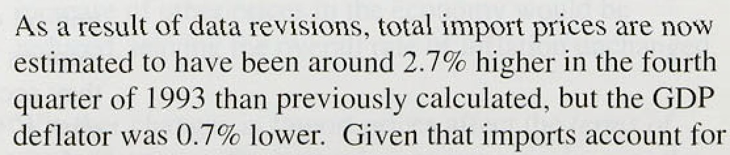

high commodity content, and which, in aggregate, account for 17&• of manufacturing output! value.

The impact of higher commodity prices on retnil prices will be further diluted. A number of food prices, for example, will be insulated by the pricing arrangements of the Common Agricultural Policy (CAP). Non-CAP foods, however, will be affected—the increase in coffee prices is already affecting retail prices. But, continuing competition in .the food-retailing industry suggests that companies will not immediately pass on the full increase in costs to their customers.

Supply-driven non-oil commodity price shocks are often temporary. Bank research suggests that demand-driven changes in non-oil commodity prices may also be partly transitory. Non-oil commodity prices tend to ‘overshoot’ in response to changes in G7 demand.

Moreover, with Japan and continental Europe only recently Showing signs of recovery, *world* demand is not yet growing sufficiently rapidly to close the aggregate 'output gap’ to which the relative prices of commodities have in the past tended to respond. But this .relatively sanguine view will have to be revised if commodity price increases continue at the rate lseen in the second quarter, .feeding through into distribution costs, and .the prices of imported semi-manufactures and (inished goods bought by UK producers.

5 2 M n

Margins are:estimated by comparing the changes in firms' domestic output prices with the.changes in the prices they pay for the various factors of production.

Manufacturers’ .margins are estimated to have,grown by 2.5% in the year to May—see Table S.A. As explained in the box on page 40, .large revisions,to import price

.data suggest that maiiufacturers’ margins grew less quickly over the last 118 months .than previously thought. The latest data suggest that, followlng,a squeeze ih 1993, margins have’been gmwitig faster .than output prices for the. past five months. But:both factor 1ahd1.output, prices remain subdued..

)8

**Tablt”S.A**

**hggnufacturing input priees, margins.and output p+\*** *







Q2

. Q3







Manufactured



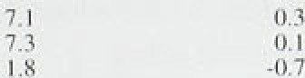

0.9 9.4



-0.g 9.2



2,2 5.5



0.8 I .4

:l.3 2.3

Mnerialx and







4.0



-0.1



1.0

2.3

**Bough\-ia**



s.3



5.6

3.

4.2

3.3

4:4

3.6



3.2

4.3



3.8



3:9



34

L9



I .9

1.4

2. I

l6.3



4.7

-1.8

-0.8

-2.9

-5.0

1.8

SO

3.8

6.U

5.4

5.0

2.3



5,8

4.11



2.6

2.3



z.7



2.6





.(*1.

approximately 309c of total domestic demand. and assuming that imports and domestic costs pass through equally quickly into final consumer prices. then the upward revision to import prices will effectively be offset by the revision to domestically generated costs (including profit margins), implying broadly unchanged inflationary pressure overall.

The method used to estimate manufacturers’ margins has been adapted to estimate retailers’ margins. Bank estimates suggest that retailers’ margins declined by nearly 10 in the year to the second quarter of 199a the seventh successive quarter to show a decline.

However, this decline was not as severe as in each of the four quarters in 1993. It appears that retailers, although facing higher costs, have not been able to pass these on to their customers fully during the last 21 months. Cost growth has, however, fallen since 1993 Q3, when the

.annual growth rate of weighted average costs was estimated at 5.0%, the highest rate for over two years; it currently stands at 2.0%. Retailers’ output prices,

.nevertheless, remain weak.

Competitive pressures have been forcing both manufacturers and retailers to.absorb increases in :costs.

' Given that margins can be viewed as a firm’s behavioural response to cost factors and market conditions, there is a concern that the current squeeze on margins:.is not sustainable and that firms may attempt to **increase** their margins. i.n.the coming months.

Companies,.however; continue to report.to.the Bank’s Agents that,they see cost reduction and hi.gher.output, rather thanhigheyprices„ as the maim:soute by which to in&aaié their profitability.

In llatitin Re Lori: A i" .a I 9'?4

## Manufacturers* margins:dnd data revisions

The Bank's latest calculâtious suggest that

:manufacturérs’ margins grew.by 6:0%..in.the year to: February. This contiasts itli the Estimate in the May f///‹ition Report.that margins grew,ñy 10. l % oyer

.that period. Between ! 992.and 1993, margins are now estimated .to .have fallen by l.89c instead of rising by 1.8 'p.,

The revisioiis to.the estimates of margins are almost entirely attributable to higher estimated

.semi-manufactured import prices (see the table). We estimate that these imports account for around t77‹ of the total value ot‘ output and margins around 229c. Every .l % point upward revision .to their estiiriated prices translates—other things being equal—into a 0:8%..tiecline in.estimated margins. Data before 1993: howéver, remain broadly unchanged.

malices I'm svns i-rim ii ut’acl urcil iiiipi iris in .Jii n uarj

pj‹ q



Vo luruc i n de.s j 1 991)= l (i(1I 

The .changes occurred\ñeeause.o‘f the:new/ system: usgd by! the. CSO to deflate i:mport: va:tires ñy volumes. The.:d3tp released›!on 12 May were the first to inco@orate tliese rev.isions. No'futther itiajor

rexisions from!thip source are.likely. The table.shows that.the esti:mated value' of se.mi-manufactured. i:mpons.hard.1y changed,.as.revisions to. prices.and” volumes:.have”offset eacli other.

Manufacturers" margins are c’alculated by first estimating their level in 1989.from the lawst- available Input-Output'Tables and tñen using the prices of.output and“i!nputs,to.estimate’subseqiiérit movements in margins.! An.assumptio* has.to.be made about the proportions!of various inputs!used. The assumption is ttiat'the relative volumes of the various .inputs used by manufacturers are fixed. lI Hence their:share of the yalue of output increases .’ when their relative.price;increases,.leaiJing to a

.decrease in the.estimate of rriargtñs:

tt

Aanueacta.ere adjust v onmexs d iop t I 'feet any increases iri’ prices, so keeping valucs constant (Cobb-Do.uglas!technolo%y): This alternative would. have impligd much small9r revisions fo margins.in lthis case. .But this assumption.leads to t›stimates of margins wh!icii.track poorly..the irregulai,'but detai.leii; estimates of margins. which can.be denved from pas!. Input-Output Tables.. This issue will be mvisited when more.up-to-.date Input-Output Tables,are publislied.



Bank calculations suggest that manufacti:rers’ margins as a percentage of selling prices—narrowed until August 1993. They then widened.until February, since when they have narrowed again. Retailers’

margins, as a percentage of selling prices, have .probably narrowed since the middle of 1992.

* ° Chart 5.2 shows that the price expectation's of consumer
  + goods firms (retailers and manufacturers) .remarked

_ subdued in .the first quaner of tñis yeir. The narrowing .of the ldivergence. between retailers’ an‹J

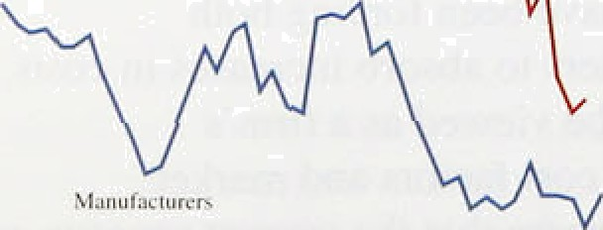

" ma.nufacturers' prlce expectatforis .siiice tlie”ffrst.quarter ' of 1992..appears consistent with the, weakening of

"' .réta.i!1ers’ margins.

The latest CBI ,Quarterly Industrial Trends Siirvey "

 showed a.po1sitive:.balance .of 1 12% .of rrianufacturing



therefore not,as suscepfi ble"to seasonal ot trend',variations,'tt'is, not surpnsing. ' ' ’ .thai'a consisteiily larger. balance.'of retailers.rcpon expect 'prices to. 6e'.rising...

40



**Chsxr5..3**

**Manul’pcturers’ reported and ’expected price developments.(CBI Industrial** Treztds **Gurvey)**







##### firms expecting to raise their prices over the next four

.months, up .from - I % in April. Seasonally adjusted, the increase was from -49a to I 3%. If realised, such increases are.likely to put upward pressure on retail prices. Chart 5.3, however, illustrates that, although reported selling prices tend to track expected prices, manufacturers .have consistently been too optimistic about their selling prices.

1. 3 t b t



**Chart 5.4**

**Return** on capital‹•›

— * Firms’ price-setting and their profitability are closely

_ „ related, and have implications for inflation and output.

Returns on capital depend on how prices move relative ” to costs and the extent to which capital is utilised.



The strong growth in profitability (see Chart 5.4) is in line with previous recoveries. although it started from a higher level, reflecting greater cost control, productivity gains and capacity utilisation. In nominal terms, industrial and commercial companies’ (ICCs ) profits increased by 2.9% in the first quarter of 1994 compared with the previous quarter, representing an annual increase of 16.6%. In comparison with their trough in the first quarter of 1992, ICCs’ total profits are now around a third higher.



- 2.

— — 0

" "I*9?0'*. 73 74 *76 GB 80 B2' B4 86 88 90 92 94

\a} Pre-tax rate of i<‹vm on capital strcL a replacement cost.

Chart 5.5

**.Ma;iufacturers’** output prices and input costs

**.(excluding.food,:drink, and tobacco)**





Chart 5.5 shows changes in manufacturers’ output prices and the costs of the manufacturing.sector.

Manufacturers’ output prices (excluding food,

beverages, tobacco and petroleum) rose by 0.4% over the quarter, with the result that the 12-month increase was 2.0% in June—the lowest rate since N.ovember 1967.

Input prices. on the other hand, rose by 1.7% over the second quarter. Commodity and other material price increases have fed through to input prices. although future purchasing and contractual arrangements will have reduced their immediate impact. The latest survey of purchasing managers shows a large rise in the cost of their raw material purchases in both May and June.

Commodity prices and firms’ price expectations both give rise .to risks to the inflation outlook. Increases in producer output prices remain constrained by market and competitive conditions, despite the rise in input prices.

The.:increase. in input prices, however, raises the concern

,that frms may seek,price increases over the coming

:months,.as reported in..the CB.I Quarterly .5urvey.. Ma'nufacturers' margi ns as a.proportion of output prices

 

are around their average of the last five years, so there is scope for change in either direction. Retailers’ margins as a proportion of output prices, however, are probably at historically low levels.

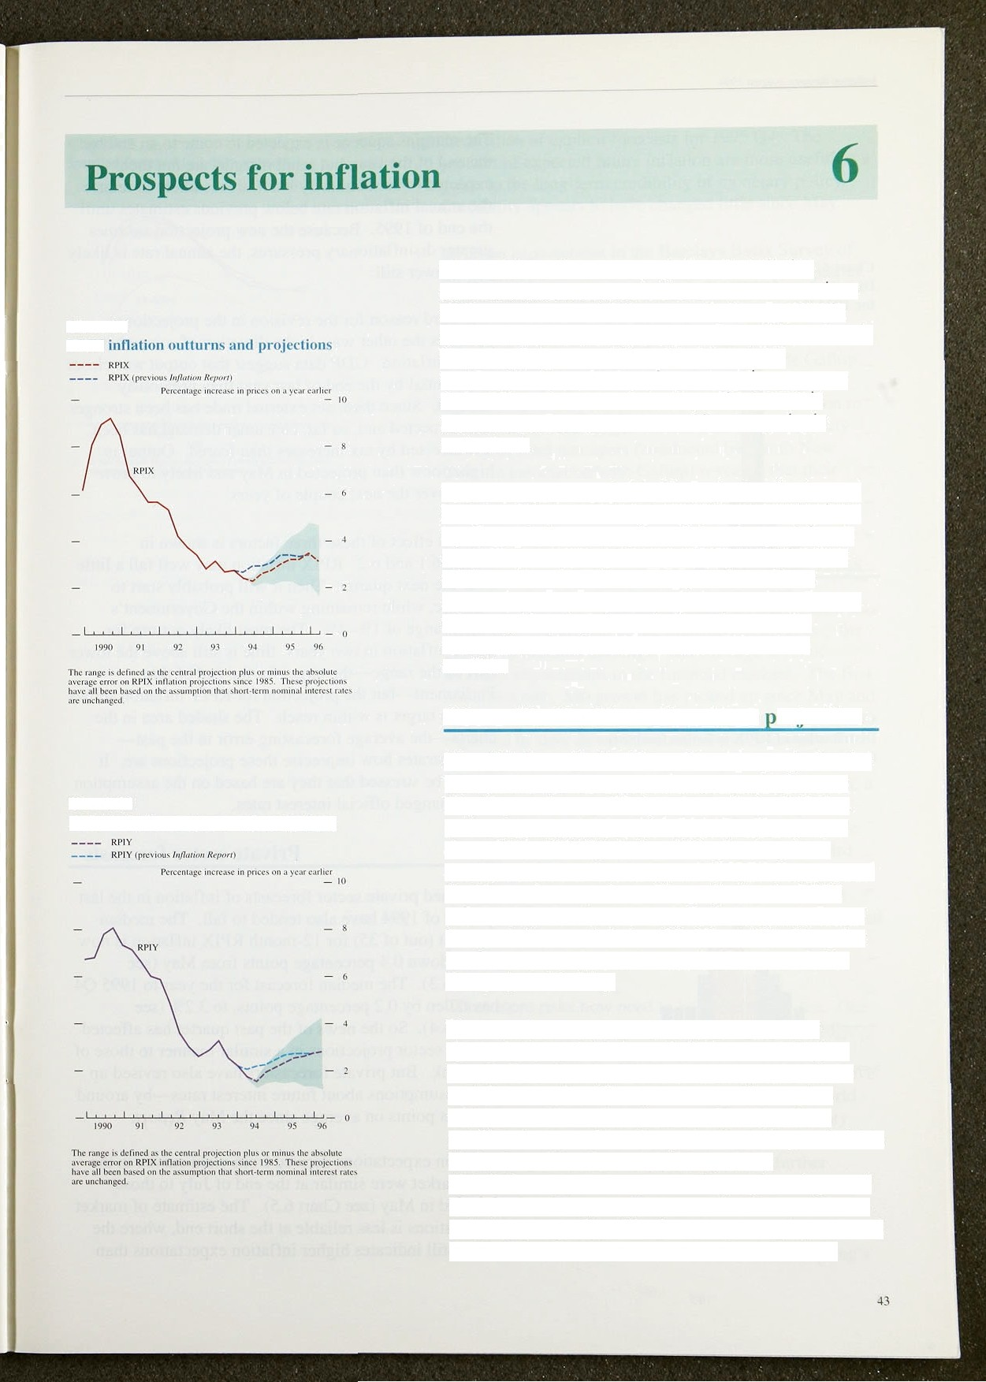

Chart 6.1

**RPIX**

Chart fi.2

RPIY **inf1ati‹›n uuttui ns and prujertiuns**

The Bank’s medium-term projection for inflation assumes that official short-term interest rates remain at 1 '/‹%—not because this is necessarily the most I ikely

outcome. but because it provides an essential benchmark for policy judgments. Given this interest rate assumption and projections for overseas interest rates derived from futures markets, the exchange rate is assumed to ensure that uncovered interest parity is maintained.

This section presents the Bank’s projection for the next two years. It also considers other inflation projections, by economic forecastei's, financial market participants and business people. These incorporate a wide range of views about how the economy works and how monetary policy might change in future. Nevertheless, taken together. they show whether others see the commitment to the inflation target of l °Ze—4*/c as credible.

* 1. **The Bank’s medium-term roiection**

Chart 6.1 shows the Bank’s medium-term projection for RPIX inflation. Compared with the projection in the May *Reyort,* the most likely outcome is that inflation will be lower until the end of 1995. It will then peak above 37c in 1996 Q1, before falling back again as announced indirect tax increases in 1995 Q2 drop out of the I 2-month comparison. The projection for RPIY inflation has also been revised but underlying inflation is expected to remain below 3% (Chart 6.2). The price *level* expected at the beginning of 1996 is now lower than projected in May.

There are three reasons why the projections have changed: two point to lower inflation, one to higher. First, inflation has been lower than expected over the past three months. The squeeze on profit margins, which started in the fourth quarter of 1993 in food

retailing, has spread to other parts of retailing, and this is likely to continue for a while. Second, the disinflationaiy pressure generated by a given degree of slack in the economy—measured by indicators like the output gap, capacity utilisation rates, unemployment and inacuvity rate has been greater than anticipated.

InfJ‹ttion R ort: August l9@4

thart 6..1

**Distribution ‹›f** RPIX inn»‹i‹» fa «» s



— 10

0

().0 (i.5 I .• I .8 *.4 ¿.fiI 1.6 J.2 4.S 3.+ 6.0



Chan 6.4

t3istribulion **uf itl•IX** inflation forecasts for 190S QJ





I I I

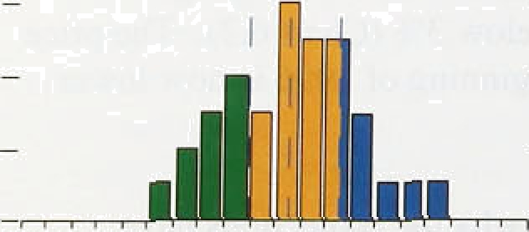

00 06 K2 t8’ 14 3.0 ’3:é +2 4:’8 14’’ 6U



##### The margins squeeze, is expected to,eome to añ end by the end of the: year,.but: retai.1 margins are: not.then expected to be rebuilt. By itse1!f, this is.likely to reduce the annual inflation rate below previous.estimates until. the end of 1995. Because the new projection assumes greater disinflationaiy pressures, the annual rate is likely to be lower still.

The third reason for the revision in the ections. operates the other way, in the direction of somewhat faster inflation. GDP data suggest that output was closer to potential by the end of last year than previously thought. Since then, net external trade has been stronger than expected and, so far, consumer demand has been less affected .by tax incr#ases than feared. Output is higher now than projected in May and likely to grow faster over the next .couple of years.



##### The net effect of these three factors is shown in

Charts 6.1 and 6.2. RPIX. inflation may well fall a little over the next quarter. Then it will probably start to increase, while remaining within the Government’s target range.of 1%—4%. The most likely outturn for RPIX inflation in two years’ time .is still above the lower half of.the range-the target for the end of this Parliament—but the projection for RPIY inflation shows that the target is within reach.. The shaded area in the charts—the average forecasting error.in the past— demonstrates how imprecise tfiese projections are. It should be stressed that they are based on the assumption

.of unchanged .oNicial interest rates.

* 1. **Private** sector **forecasts.**

##### Published private sector forecasts of inflation in the last quarter of 1994 have also tended to fall. .The median forecast.(out of 35) for .12-month.RPIX inflation is now 2.7& . down 0.4 percentage points from May (see

Chart 6.3). The median„forecast for the year to 1995 Q4 has fallen by 0.2 percentage points, to 3.2&» (see

arter has.:affected private sector projeeltiods in.a.similar mañ:her.top those 1of the Bank. But private forecasters.have also::revised up their assumptions about:future’ i:nterest rates .by around 30.basis pot.nis on! avemge since the.‘May *Aepoc,t.,*





the median.of explicit forecasts for 1995 Q4. The profiles of expected future inflation are more useful as a guide to the long-term credibility of monetary policy.



Credibility appears to have changed little since May.

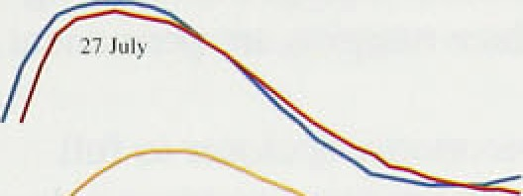

- - 3







Inflation expectations in the Barclays Basix Survey of the general public have also fallen over the past quarter. This contrasts with the CBI Industrial Trends Survey, which shows an increase in the balance of firms expecting to increase their prices in the next four months (see Section 5). However, in common with the Gallup survey of employees (see Section 4). the average expectation among the general public is for inflation to ñe 4.0% a year ahead and 4.6% a year later. The July survey of fund managers (conducted by Smith New Court in association with Gallup) .revealed that their inflation expectations have stabilised, at 3.2% for

end-1994 and 3.99r for end-1995.

* 1. The main risks

In the May *Report,* three main inflation risks were identified: the growth of the monetary aggregates; the growth of nominal earnings; and the high level of inflation expectations in the financial markets. The first remains a risk. M0 growth has picked up since May and is well above its monitoring range, although it is expected to slow down this autumn and is already showing some signs of falling. M4 growth, however, gives little cause for concern. As for earriings growth, it was no higher than projected in May, but rising taxes, falling unemployment and deteriorating terms of trade could increase the upward pressure on pay. The third risk—financial markets' inflation expectations—has hardly changed. These expectations are volatile, but

they still suggest that investors are not yet convinced that price stability can be achieved and maintained in the long term.

Three more risks.now.need to be.added to the list. One is that commodity prices will continue to rise rapidly. pushing up producers’ output prices by more.than assumed in the projection. Producers’ input prices have akeady been affected (see.Section 5). Because world demand is still sluggish, big increases in commodity prices,are unlikely to.continue for long enough to have a serious impact on domestic inflation. But further

supply-side shocks would.after the outlook.

Tiiq seéond risk’is that .margins, particularly. those of retailers, may:rebound.if firms ñeeide tliat this spring’s



##### tax increases wil!l,not lead to a significant slowdown i!n demand. This would happen if margins arelmore procyclical than assumed in thé projections. It is not clear yet whether the structural changes in retailing which have helped to reduce margins are permanent.

The third.risk is that the economy, is closer to full potential than projected. The.recent increases in land prices and costs in the construction sector raise this possibility.

The risks are not all on one side. First, manufacturing and retail margins, as a percentage of selling prices, could fall further.. The former are well above their historical trough. At some point, if margins shrink too much, the return on capital will ñe low enough to drive firms out of these industries. But profitability is probably well above this point at the moment. Second, the unexpectedly low inflation in recent.months may bring down the inflation expectations of price and wage- setters more rapidly, leading to lower nominal prices and wages than projected. Third, some labour market indicators suggest that the headline unemployment figures may be exaggerating the speed at which the labour market.is tightening and thus exaggerating the upward pressure on earnings.



In the short term. the prospect for inflation remains encouraging. Inflation was unexpectedly low in the second quarter. The Government’s measure of underlying inflation—which includes the impact of

.higher indirect taxes—remained within the lower half of the lie-49 target range. The Bank’s measure—whic h excludes indirect taxes—fell to just over I '/ %. Other measures of ‘core’ inflation have either fallen or stayed low. And underlying inflation may well fall a little further over the next quarter. In contrast. headline RPI inflation, distorted by the inclusion of mortgage interest payments, has been rising from its low in the first half of last year.

The continuing reduction in inflation reflects a squeeze in retail margins which has now spread well beyond the food sector. Part of the reduction in margins may stem from a structural change in competition. but a significant cause is the continuing disinflationary effect of the recent recession. Since then, the recovery in output has clearly reduced the output gap, which will moderate these disinflationary pressures. At some point, the downward pressure on inflation resulting from excess capacity in goods and labour markets will be offset by the upward pressure resulting from growth above trend. Provided output growth (relative to the trend) is not allowed to become too rapid, the increase in inflation can be held in check.

At present, non-oil output is rising at an annual rate of roughly 3% or so, and nominal GDP is growing at around 6%. .Broad.money is also rising at around the middle of its medium-term monitoring range of 3%—9 . These aggregate figures are consistent with continued

.recovery and low inflation. And the three risks to the inflation outlook highlighted in the May *Report—* monetary growth, increases in earnings and a rise in inflation expectations—have become no worse. Indeed, the first has receded.a little with the first signs of a deceleration in narrow money.

Btit.,il:es:ñ!data do. notlreveal the full picture. In some

’’ .sectors, sig!ns:of possible inflationary pressures are beginni!ng to:appeal. . Despite the patchy upturn in the houaiirg !mnrketi which has been weaker over the past:





quarter,!land prices. have.for.some .time been rising sharply from .a low level, and costs and prices in construction are rising:. Theresa tentative reports of recruitment difficulties .in some sectors—not confined to1 the highly skilled—and manufacturing .input prices have risen by 3% in three months. Capacity utilisation, as measured by the **CBI,** .is above its historical average.

The numbet of firms reporting an intention to raise prices has increased significantly over the past three months and has remained high for the second successive month. By itself, no single indicator is particularly significant. Taken together, they suggest the need to be alert to future inflationary pressures.

The Bank’s projection .fpr inflation in the short run has fallen since the May *Report.* But the outlook for two years hence is virtually unchanged. Assuming unchanged official interest .rates, underlying inflation is

.expected to rise into the top half of the target range.

The stance of monetary policy must ñe lset on the basis of,a judgment of where .inflation will be in some two years or so. This is especially i!mportant at turning- points in official interest rates. Although it is uncomfortable to base policy on a forecast that is subject to a large margin of error, the .lags between changes in interest rates and subsequent changes in inflation mean that there is no.simple (or for that matter complicated) alternative to forming a judgment about the future path of inflation conditional upon all current information.

The pressures for higher inflation fn the future may be building up even as the published inflation rate for the past continues to fall. It is possible, through not yet certain,.that the United Kingdom is entering this phase. The .current picture .of output gFowing above trend and inflation continuing to fall remains .favourable., But if official interest rates were to remain unchanged over the next two years, then it is probable that infladon would gradually rise to a level above the mid-point of the target range.

48

